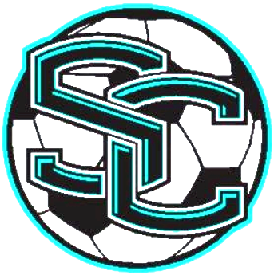

SWIFT CREEK
SWIFT CREEK

# | Name | Grade | Pos.
1 | Connor Stroud | 7 | M
2 | Brantley Snowden | 8 | D
3 | Alex Aguirre | 8 | M
4 | Bryce Correa | 8 | M
5 | Justin Smith | 7 | M
6 | Sean Yearwood | 7 | M
7 | Dakotah Marshall | 8 | M
8 | Nick Molinaro © | 8 | D
9 | Ky Peltier © | 8 | M
10 | Yunus Kovankaya © | 8 | F
11 | Ahmet Bilgili | 8 | M
12 | Britton Blake | 8 | D
13 | Hunter Peschl | 8 | G
14 | Grayson Montgomery | 8 | F
15 | Noah Thurston | 8 | M
16 | Emir Bilgili | 7 | D
17 | Parker Simpson | 7 | D
18 | Ryan Nieto | 7 | D
19 | Elijah Hendley | 6 | D
20 | Weston blake | 6 | F
21 | Cole Turner | 6 | G
22 | Isaiah Hendley | 8 | D
23 | Gage Ritchie | 7 | M
24 | DArrick Waller | 7 | F
35 | Evan Quigley | 8 | D
Head Coach: Robert Hanna
Assistant Coaches: Ashley Murphy & Scott Montgomery
manager: Caden Jensen
Principal: Sue Rishell
Athletic Director: Kelly Lynch
Assistant Principals: Kathy Culley & Patrick Wright

SWIFT CREEK
SWIFT CREEK

# | Name | Grade | Pos.
1 | Connor Stroud | 7 | M
2 | Brantley Snowden | 8 | D
3 | Alex Aguirre | 8 | M
4 | Bryce Correa | 8 | M
5 | Justin Smith | 7 | M
6 | Sean Yearwood | 7 | M
7 | Dakotah Marshall | 8 | M
8 | Nick Molinaro © | 8 | D
9 | Ky Peltier © | 8 | M
10 | Yunus Kovankaya © | 8 | F
11 | Ahmet Bilgili | 8 | M
12 | Britton Blake | 8 | D
13 | Hunter Peschl | 8 | G
14 | Grayson Montgomery | 8 | F
15 | Noah Thurston | 8 | M
16 | Emir Bilgili | 7 | D
17 | Parker Simpson | 7 | D
18 | Ryan Nieto | 7 | D
19 | Elijah Hendley | 6 | D
20 | Weston blake | 6 | F
21 | Cole Turner | 6 | G
22 | Isaiah Hendley | 8 | D
23 | Gage Ritchie | 7 | M
24 | DArrick Waller | 7 | F
35 | Evan Quigley | 8 | D
Head Coach: Robert Hanna
Assistant Coaches: Ashley Murphy & Scott Montgomery
manager: Caden Jensen
Principal: Sue Rishell
Athletic Director: Kelly Lynch
Assistant Principals: Kathy Culley & Patrick Wright

