Name: ______________________________ Pd: 3 Week 3 Distance Learning
Thermal Energy
Use the resources found on Mr. Hanna’s website to help you respond to the following items.
VOCABULARY:
- TEMPERATURE
- THERMAL ENERGY
- HEAT
- CONDUCTION
- CONDUCTOR
- INSULATOR
- CONVECTION
- RADIATION
SHORT ANSWER:
- Explain the relationship between “thermal energy,” “temperature,” and “heat.”

- Compare the three common temperature scales in the table below.
Temp. Scale | FAHRENHEIT | CELSIUS | KELVIN
Metric System? (Y or N)
Freezing Point of Water
Boiling Point of Water

- How does the kinetic energy of the molecules in a substance relate to the temperature/phases?

- Describe possible effects of adding thermal energy to a substance (or removing it from the substance)?

- How is the energy required to raise the temperature of a substance related to the specific heat of the substance?

- The specific heat of water is 4.18 ^{J}/_{g⁰C}. If you are heating 500g of water from a temperature of 20⁰C to a temperature of 100⁰C, how many Joules of thermal energy will be required? (show your work)

- Compare the three types of heat, convection, conduction, and radiation (how they are similar/different).

- Differentiate conductors and insulators (how they are different). (note – your answer should address density)

- What causes a convection current? (note – your answer should address density)

- What evidence do we have that radiation can transfer thermal energy through empty space?

- If I hand you a can of soda that I got from the refrigerator, explain why your hand would feel cold when you touch the can.

- Explain the expression, “There’s no such thing as cold.”

INTERPRETING A GRAPH: Use the phase change graph below to answer the following questions.
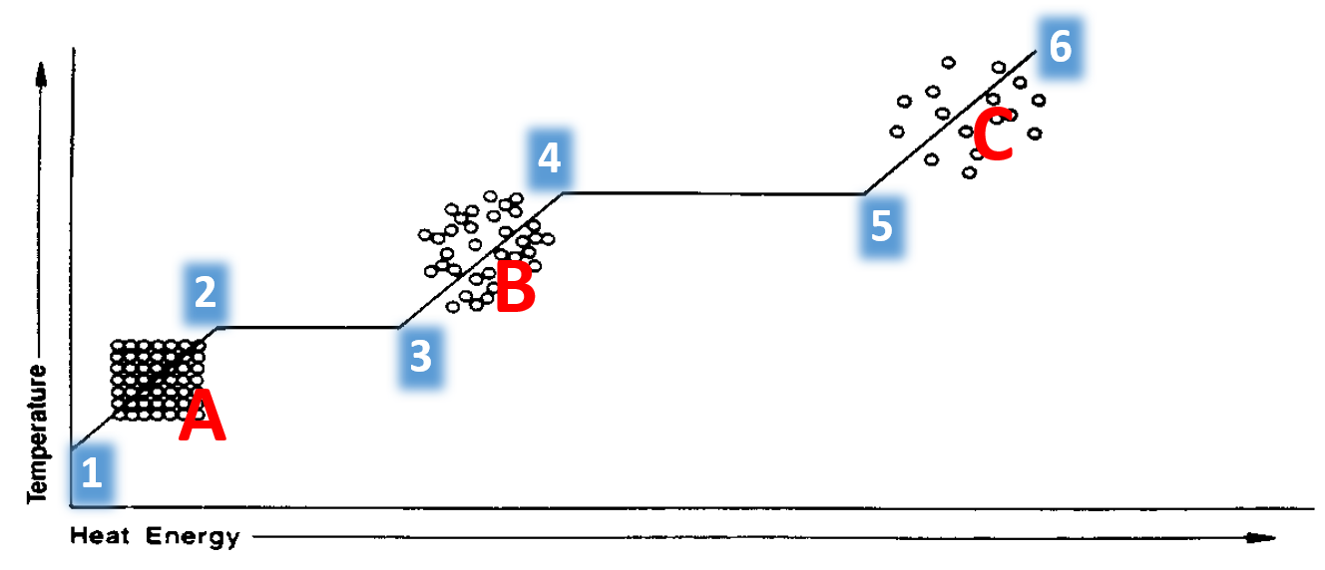

- Label the state of matter present at each position below:

- What is happening to the substance during each interval below?
  - Between positions 1 and 2 –
  - Between positions 2 and 3 –
  - Between positions 3 and 4 –
  - Between positions 4 and 5 –
  - Between positions 5 and 6 –
- Is thermal energy being added to this substance or removed from this substance between positions 1 and 6? What evidence do you have?

- Which positions on this graph would you use the equation “Q=mcΔT” to determine how much thermal energy transfer is required?

- Which positions on this graph would you use the equations “Q=mL_{f}” or “Q=mL_{v}” to determine how much thermal energy transfer is required?

