Name: ______________________________ Pd: 3 Week 4 Distance Learning
Mechanical Energy
Use the resources found on Mr. Hanna’s website to help you respond to the following items.
VOCABULARY:
- MECHANICAL ENERGY –
- KINETIC ENERGY –
- POTENTIAL ENERGY –
- ELASTIC POTENTIAL ENERGY –
- GRAVITATIONAL POTENTIAL ENERGY -
SHORT ANSWER:
- What metric unit do we use to measure energy (including mechanical energy)?

- What two variables affect an object’s kinetic energy?

- Compare elastic potential energy with gravitational potential energy (how they are similar & different).

- What two variables (aside from the acceleration due to gravity, “g”) affect an object’s gravitational potential energy?

INTERPRETING A DIAGRAM: Use the diagram of a swinging pendulum below to answer the following questions.
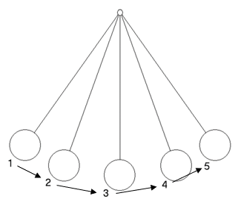
- At which point(s) on the diagram would the ball have maximum (the greatest) potential energy? Why?

- At which point(s) on the diagram would the ball have maximum (the greatest) kinetic energy? Why?

- At what point(s) on the diagram would the ball have BOTH kinetic energy and potential energy?

- Describe how the energy in the ball changes as it moves from position 1 to 2 to 3 to 4 to 5.

PRACTICE PROBLEMS: Use the scenario described below to answer the following questions.
A 1.5 kg book is sitting on the edge of a desk that is 0.75 m tall. A student accidentally bumps the desk, causing the book to fall to the ground. Another student picks up the book, putting it back in its original position on the desk.

- How much gravitational potential energy did the book have as it rested on the desk?

- At one instant during its fall, the book has a velocity of 3 m/s down. How much kinetic energy does the book have at this instant?

