Name: ______________________________ Pd: 3 Week 5 Distance Learning
MOTION
Use the resources on Mr. Hanna’s website to complete the following assignment.
VOCABULARY:
- REFERENCE POINT –

- SPEED –

- VELOCITY –

- ACCELERATION –

- SLOPE –

SHORT ANSWER:
- How can you tell if an object is moving?

- How is a “scalar” different from a “vector”? Which of these would characterize speed? Which would characterize velocity?

- List three ways an object can accelerate (3 ways to change velocity).

- When you’re calculating acceleration and get a negative number, what does that tell you?

- What can you learn by calculating the slope of a line on a distance vs. time graph? How do you calculate slope?

PRACTICE PROBLEMS: (remember to show your work – 3 steps!)
- How fast is a turtle moving if it crawls 1.5 m in 60 s?

- What is the velocity of a car if it takes 5 s for it to drive 55 m?

- What is the acceleration of a golf cart if it takes 4 s for it to speed up from 0 m/s to 10 m/s?

INTERPRETING GRAPHS:
- What does a straight line with a positive slope mean on a displacement vs time graph? What does a straight, negative slope mean?

- What does a curved line mean on a displacement vs time graph?

Use the graph below to answer the following questions.
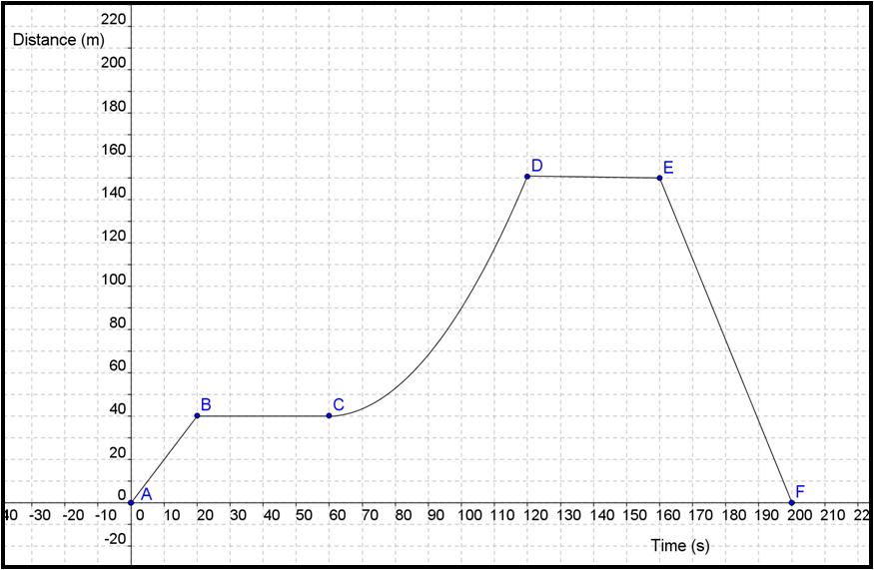

- Describe the motion of the object that resulted in the graph above. (What did the object do to create this data?)

- Identify at least two places on this graph where the object accelerated.

- How fast is the object moving between points A and B?

- How fast is the object moving between points B and C?

- Compare the motion of the object between A and B to the motion of the object between E and F.

