**A System and Its Surroundings** Name: ______________________________ Pd: _____ Ast: _____

**U.C. Davis ChemWiki**

<http://chemwiki.ucdavis.edu/Physical_Chemistry/Thermodynamics/A_System_And_Its_Surroundings>

**Introduction**

A primary goal of the study of thermochemistry is to determine the quantity of heat exchanged between a system and its surroundings. The **system** is the part of the universe being studied, while the **surroundings** are the rest of the universe that interacts with the system. A system and its surroundings can be as large as the rain forests in South America or as small as the contents of a beaker in a chemistry laboratory. The type of system one is dealing with can have very important implications in chemistry because the type of system dictates certain conditions and laws of thermodynamics associated with that system.

**Open System**



Note: the diagram depicting the transfer of energy and matter is showing how energy and matter can enter the system **AND** leave the system. Do not be fooled by the one way arrows.

An **open system** is a system that freely exchanges *energy* and *matter* with its surroundings. For instance, when you are boiling soup in an open saucepan on a stove, energy and matter are being transferred to the surroundings through steam. The saucepan is an open system because it allows for the transfer of matter (for example adding spices in the saucepan) and for the transfer of energy (for example heating the saucepan and allowing steam to leave the saucepan).

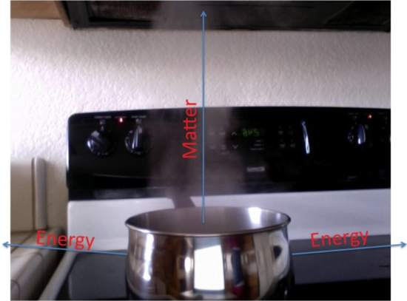Let us examine how matter and energy are exchanged in an open system. Matter can be exchanged rather easily: by adding matter (i.e spices) or removing matter (i.e tasting what is being cooked). Energy exchange is a little bit more complicated than matter exchange. There are a couple of ways energy can be exchanged: through heat and through work (a more in-depth discussion of heat and work has been included below). Energy induced through heat can be demonstrated by bringing the system close to an object that dissipates heat (i.e. Bunsen burner, stove, etc.). By doing so, one is able to change the temperature of the system and therefore, induce energy through heat. Another way to increase the energy is through work. An example of inducing work is by taking a stirrer and then mixing the coffee in the cup with the stirrer. By mixing coffee, work is done as the coffee is being moved against a force.

**Closed System**

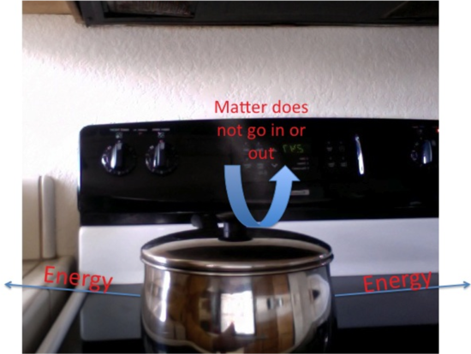Putting a lid on the saucepan makes the saucepan a closed system. A **closed system**is a system that exchanges **only energy** with its surroundings, not matter. By putting a lid on the saucepan, matter can no longer transfer because the lid prevents matter from entering the saucepan and leaving the saucepan. Still, the saucepan allows energy transfer. Imagine putting the saucepan on a stove and heating it. The saucepan allows energy transfer as the saucepan heats up and heats the contents inside it. For example, when a lid is put a beaker, it becomes a closed system. Next, when the contents in the beaker are boiled, the sides of the beaker will start getting foggy and misty. This fog and mist is the steam which covers the sides of the container because it cannot escape the beaker due to the lid. The fact that the beaker is able to produce this steam means that the beaker allows for energy transfer. Thus, even though a closed system cannot allow matter transfer, it can still allow energy transfer.



Note, the blue diagram is showing how energy can enter the system **AND**leave the system. Do not be fooled by the one-way arrows.

The methods of energy transfer in a closed system are the same as those described for an open system above.

**Isolated System**

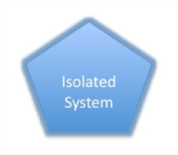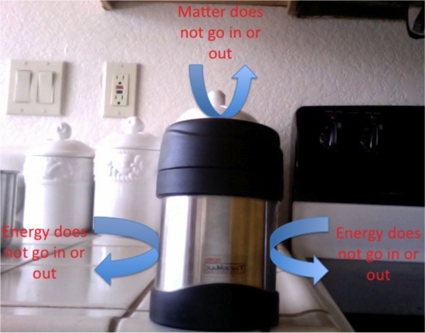Now let's examine the type of system you have if you substituted a thermos for the saucepan. A thermos is used to keep things either cold or hot. Thus, a thermos does not allow for energy transfer. Additionally, the thermos, like any other closed container, does not allow matter transfer because it has a lid that does not allow anything to enter or leave the container. As a result, the thermos is what we call an isolated system. An **isolated system** **does not exchange energy or matter** with its surroundings. For example, if soup is poured into an insulated container (as seen below) and closed, there is no exchange of heat or matter. The fact that, in reality, a thermos is not perfect in keeping things warm/cold illustrates the difficulty in creating a truly isolated system. In fact, there are few, if any, systems that exist in this world that are completely isolated systems.

**Applications**

Systems and surroundings have many practical applications in chemistry as well as in our own day-to-day lives. Without even knowing, we interact with thousands of closed and open systems everyday. For example, when packing lunch, food is normally placed in some sort of closed container (so that things don't enter or leave the container). Anything can be defined as a system, and and everything else would then be the surroundings.

In reality, the type of system one is dealing with has many implications regarding the assumptions and calculations one is allowed in chemistry. Furthermore, based on systems and surroundings, scientists have come up with a couple of laws known as laws of thermodynamics. The [first](http://chemwiki.ucdavis.edu/Physical_Chemistry/Thermodynamics/Laws_of_Thermodynamics/First_Law_of_Thermodynamics)and [second](http://chemwiki.ucdavis.edu/Physical_Chemistry/Thermodynamics/Laws_of_Thermodynamics/Second_Law_of_Thermodynamics) law of thermodynamics, briefly stated, are: 1) The internal energy of an isolated system stays constant. 2) The entropy of an isolated system tends to increase.

The first law is based upon the definition of an isolated system. Internal energy is a sum of a system's heat and work. As discussed earlier, heat and work are forms of energy. An isolated system is by definition a system that does not allow energy transfer. Thus, it makes sense to say that the internal energy of an isolated system stays constant because it does not change at all.

The second law of thermodynamics, increasing entropy of an isolated system, asks for basic understanding of entropy. Entropy is the disorder within a system. For example, a solid has no disorder (atoms are packed into a cube and cannot move) whereas a gas has more disorder (atoms bouncing all over the place). Thus, this law states that the entropy of an isolated system tends to increase (i.e. a chemical reaction taking place in an isolated system will never have a liquid becoming a solid because that is a decrease in entropy).

The topic of a system and surroundings, just like other topics in chemistry, is one that can be well understood through reading and visualizing examples. An open system is one that allows energy and matter exchange. When deciding whether or not something is an open system, one must determine whether or not the system allows matter and energy transfer. If it does, then it is an open system. If it does not, then it is either a closed system or an isolated system. If the system allows neither energy or matter transfer, then it is an isolated system. However, if it allows only energy transfer, it is a closed system.

**Discussion Questions: Answer the following questions on your own sheet of notebook paper**

1. Consider the Atlantic Ocean, a pizza delivery bag (closed with pizza inside), and a greenhouse (closed with plants inside). Classify the type of system for each example and provide evidence from the text to support your claim.
2. A thermos contains hot chocolate with a temperature of 80⁰C. If the thermos is left out in a room where the outside temperature is 20⁰C, what would happen to the temperature of the hot chocolate inside the thermos (*assume the thermos is 100% efficient*)? Provide evidence from the text to support your explanation.
3. The first law of thermodynamics says that energy within an isolated system is conserved. What about the energy in an open system or a closed system, is it conserved as well? Explain your answer.
4. A basketball is dropped onto the gym floor and, after bouncing a few times, it eventually comes to rest on the floor. Explain this scenario in terms of energy and systems. Use evidence from the text to support your answer.