Name: ______________________________ Pd: _____ Ast: _____

Chemical Reactions Lab

Introduction: When substances undergo chemical changes they become different substances with different properties because their chemical bonds have changed. Chemical changes are often accompanied by the following:

- Temperature changes (sudden heating or cooling)
- Color change
- Bubbles (sign of gas formation)
- Flame/Light
- Formation of a new substance with different properties

When the reactants calcium chloride, baking soda, and phenol red solution are combined, a chemical reaction takes place as evidenced by heat given off, a change in color, and the production of bubbles (gas). In this investigation you will attempt to determine which reactants are responsible for each of these signs of a chemical reaction.

Your Task: Perform an investigation to determine which reactants are responsible for each of the indicators of a chemical change present in this reaction. (You should also determine which reactants are NOT necessary for each.)

The guiding questions of this investigation are: Which reactants are responsible for causing the heat? Which reactants are responsible for the yellow color change? Which reactants are responsible for the gas formation?

Materials: You will use the following materials during your investigation.
- Plastic Bags  - Small Vial (for wet reactants)  - Scoops (for dry reactants)  - Water  - Phenol Red Solution (phenol red and water) | - Baking Soda (“two scoops” per trial)  - Calcium Chloride (“two scoops” per trial)  - Safety Goggles  - Safety Apron

Safety Precautions:
- Wear safety goggles and a safety apron at all times.
- Never directly smell the chemicals – use wafting instead.
- Never taste or directly touch the chemicals with your skin – use tools and containers when handling the chemicals. You can feel the reaction through the bag.
- Keep expanding bags away from your face. Open the bag over the sink pointing away from you to release the gas.
- Clean up all spills promptly to avoid slips and falls. All reactants and products are non-toxic.

Getting Started:
- The original chemical reaction actually had four reactants. The phenol red solution is a mixture of phenol red powder and water. For your testing you may evaluate the following reactants:
  - 10 g Calcium Chloride (two scoops)
  - 10 g Baking Soda (two scoops)
  - 10 mL Phenol Red Solution (Phenol red powder + water)
  - 10 mL Water
- Use your sense of sight, hearing, touch (through the bag only), and smell (wafting) to make observations.
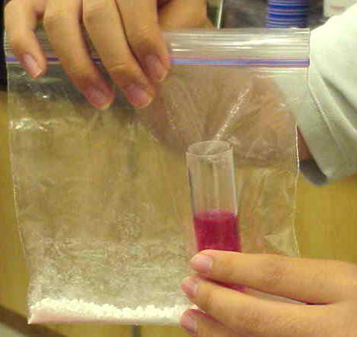
- A method for combining reactants:
  - Place the dry chemical(s) into the bag on opposite corners.
  - Place the proper amount of the liquid chemical(s) into a small vial.
  - Carefully lower the vial into the bag without spilling it contents (this usually takes some teamwork).
  - Seal the bag, tip the contents of the beaker or film canister onto the substance at the bottom of the baggie and mix it all together with your fingers.
  - Observe the changes that take place.
- On the back of this paper, record the reactants being tested in each trial as well as your data/observations as you work through this investigation.
- Answer the questions on the back of the paper.
Chemical Reactions Lab Sheet
- DATA

- HEAT
- Which combination of reactants give off heat when they are mixed?
- What evidence do you have that these are the reactants responsible?

- COLOR
- Which combination of reactants cause a yellow color change when they are mixed?
- What evidence do you have that these are the reactants responsible?

- GAS
- Which combination of reactants produce a gas when they are mixed?
- What evidence do you have that these are the reactants responsible?

- CHEMICAL REACTIONS
- What evidence do we have that a chemical reaction occurred in the bag when all of the reactants were mixed?

- How do the reactants (the things present before the reaction) compare to the products (the things present after the reaction) when all of the reactants are mixed?

- Once you put all of the reactants in the bag and sealed it, were any atoms added to the system? Were any atoms removed from the system? What does this mean about the reactants and products of this reaction?

