Name: ______________________________ Pd: _____ Ast: _____
Atoms Practice & Study Guide
ON A SHEET OF NOTEBOOK PAPER, RESPOND TO THE FOLLOWING ITEMS TO PREPARE FOR THE ATOMS QUIZ.
- Use the diagrams below to answer the following questions.
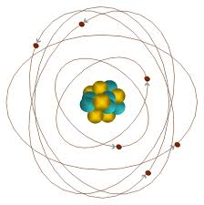
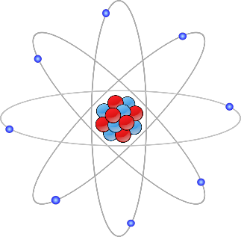
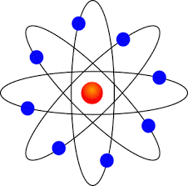
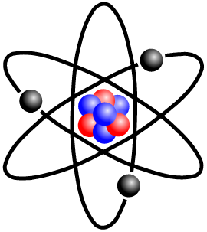
- B. C. D.

  - Which of the diagrams show electrons orbiting a nucleus? ALL
  - Which of the diagrams does not show neutrons as part of the atom? B
  - Which diagram does the best job of showing the relative size/mass of electrons? C (or none)
  - Which diagram does the best job of showing the concept of energy levels within the electron cloud? C
  - Which of the diagrams misrepresent the relative size of the nucleus compared to the electron cloud? ALL
- Use the information about each element below to answer the following questions.
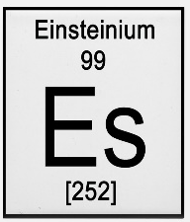
For Einsteinium, identify the:
- Atomic Number – 99
- Atomic Mass – 252

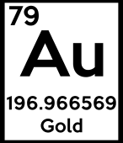
- What is gold’s atomic number? 79
- How many protons are in a gold atom? 79
- What is the atomic mass of gold? 196.97a.m.u.
- How many sub-atomic particles are in the nucleus of the average gold atom? 197
- Most gold atoms have 118 neutrons, some have 117. What is the term for these two types of gold atoms? ISOTOPES

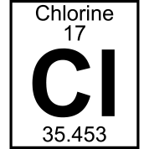
- How many protons are in a chlorine atom? 17
- Chlorine’s atomic mass is 35.453, what does this mean? @35 PARTICLES IN THE NUCLEUS
- How many electrons would be in a neutral atom of chlorine? 17
- Chlorine often takes in an extra electron. What kind of atom does it become when this happens? ION (NEGATIVE ION)

- ELEMENTS – Use the information provided about each element to answer the questions below.
boron  5  B  10.811 | carbon  6  C  12.011 | nitrogen  7  N  14.007 | oxygen  8  O  15.999 | fluorine  9  F  18.998 | neon  10  Ne  20.180

- What makes a carbon atom different from a nitrogen atom? CARBON HAS 6 PROTONS, NITROGEN HAS 7
- On average, which of the elements shown above has the most particles in its nucleus? NEON (@20)
- How many protons are in the nucleus of a fluorine atom? 9
- What is boron’s atomic mass? 10.811 a.m.u.
- What is the atomic number for oxygen? 8
- Carbon¹² has 6 neutrons, carbon¹³ has 7 neutrons, and carbon¹⁴ has 8 neutrons. What is the term for these atoms? ISOTOPES
- Sometimes a fluorine atom will gain a tenth electron, causing it to have a negative charge. What is the term for this type of atom? ION (NEGATIVE ION)
- Identify the correct word for each definition/clue
- ELEMENT - a substance made of only one kind of atom
- ION - an atom that has a charge because it has gained or lost electrons
- NUCLEUS - the region at the center of an atom that contains most of the mass of the atom
- ATOMIC NUMBER - the number of protons in the nucleus of an atom of an element
- ISOTOPES - atoms of the same element with different numbers of neutrons
- PROTON - a positively charged (+) particle in the nucleus of an atom
- ELECTRON - a negatively charged (-) particle that occupies the space outside the nucleus
- NEUTRON - an uncharged (Ø) particle in the nucleus of an atom
- ELECTRON CLOUD - the region surrounding an atom’s nucleus where electrons orbit
- ELECTRON - the only sub-atomic particle NOT found in the nucleus
- NEUTRON - the only sub-atomic particle that does NOT have a charge
- ELECTRON - by FAR the LEAST massive of the sub-atomic particles
- NEUTRON - has the same mass as a proton
- PROTON - determines the type of atom, or the element
- Provide a short response for the following questions.
- Where did the modern word, “atom”, come from? Describe Democritus’s thought process that led to this idea. The word, “atom”, comes from the Latin “atomos” meaning “uncuttable”. Democritus theorized that if you were to cut an object in half over and over, eventually you’d be left with the smallest individual particle of matter.
- John Dalton was the first modern scientist to expand on Democritus’ theory of atoms. What were the three main components of Dalton’s atomic theory? How did he envision the atom? 1 – All matter is composed of atoms, 2 – each element has a specific type of atom that is unique to that element, 3 – atoms are the smallest individual unit of matter and cannot be subdivided (cut) or destroyed.
- Dalton envisioned the atom as a tiny, solid ball of matter.
- How did JJ Thomson change the way we understand atoms using a cathode ray tube? Describe how he changed our model of the atom as a result. Thomson put a magnet near a cathode ray tube and bent the beam. He concluded that the beam was made of negatively charged particles that became known as electrons. These electrons were embedded into the tiny, solid ball model (Muffin Model).
- Hantaro Nagaoka proposed an interesting new version of an atomic model. Unfortunately, Nagaoka lacked evidence for his atomic theory. Describe his vision of what an atom looked like. Nagaoka envisioned the atom like a solar system, with the Sun as a positive nucleus orbited by negative electrons (like planets).
- Earnest Rutherford set out to provide evidence for J.J. Thomson’s atomic model using the Alpha Particle Cannon. Describe his investigation and explain how it resulted in supporting Nagaoka’s version of the atom rather than Thomson’s. Rutherford shot alpha particles at gold foil, expecting them to pass right through. While most of them did, some bounced back. This provided evidence that while most of the atom is made of empty space, there is a very small, dense, positively charged nucleus in the center.
- Neils Bohr came up with a way to describe the behavior of atoms (specifically, electrons), comparing them to an onion. Explain his idea and how we use it today. Bohr said the electrons behave as though they move on layers within the electron cloud. Electrons on the outer-most layer are called valence electrons, and are important in chemical bonding.
- Ernest Rutherford began to realize that hydrogen nuclei were present in other atoms. Explain how these hydrogen nuclei eventually became known as a sub-atomic particle themselves. Rutherford slowly realized that the alpha particles he shot at the gold foil were the nuclei of hydrogen atoms. Over time, he realized that these nuclei consisted of a positive sub atomic particle which became known as a proton.
- Why was James Chadwick’s discovery of the neutron so important in understanding atoms? ? Up until then, the mass of atoms that scientists predicted based on the number of protons was always half that of the observed mass of atoms. Neutrons explained where the “extra mass” came from.
- Why do we call the modern model of the atom the “electron cloud” model? The electrons orbiting the nucleus are difficult to pinpoint, so we discuss them in terms of probabilities instead. Certain regions (layers) of the atom are likely to have certain electrons.
- The Atom – Complete a table as shown below comparing the characteristics of sub-atomic particles.
Characteristic | Electron | Proton | Neutron
Mass (relative to the others) | 2000x smaller than protons | 2000x more than electrons | same as protons
Charge | Negative  (-1) | Positive  (+1) | Neutral  (0)
Location in the Atom | Electron Cloud  surrounding nucleus | Nucleus | Nucleus
- If a sodium atom has 11 protons, 12 neutrons, and 10 electrons…
  - What is its atomic number? 11
  - What is its atomic mass? 23 (11+12)
  - Is it an ion? If no, why not? If yes, what is its charge? Yes, it is an ion with a charge of +1 (11 protons and 10 electrons means 1 more positive charge than negative)

