Name: _______________________________ Pd: ___ Ast: _____
PROPERTIES OF GASES STUDY GUIDE
Describe the behavior of ideal gases according to each of the gas laws below:
- Boyle’s Law – PRESSURE is inversely proportional to VOLUME
- Charles’s Law – VOLUME is directly proportional to TEMPERATURE
- Gay-Lussac’s Law – PRESSURE is directly proportional to TEMPERATURE
- Avagadro’s Law – VOLUME is directly proportional to the AMOUNT of gas
For an ideal gas, keeping all other variables constant, describe the relationship between:
- temperature and pressure – P α T – When temperature goes down, so does pressure
- temperature and volume – V α T – When temperature goes down, so does volume
- pressure and volume – P α 1/V – When volume goes down, pressure goes up

For each real-life scenario, use the gas laws to explain the behavior of gases.
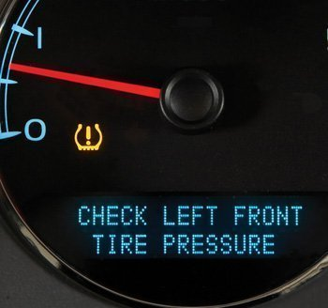
- On a cold morning, your parent starts up the car and the tire pressure light comes on signaling low tire-pressure.
When the temperature decreases, the particles in the gas move slower because they have less energy. As a result, they push with less force on the sides of their container. This results in a lower pressure. The cold air caused the air in the tire to have lower pressure because the gas molecules are moving slower. This is an example of Gay-Lussac’s Law, which states that the pressure of an ideal gas is proportional to the temperature, assuming the volume of the tire is relatively constant.
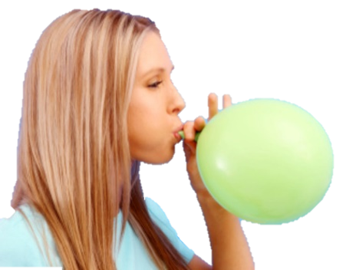
- You fill up two balloons with the same amount of air. You place one in sunlight for an hour and the other in your refrigerator for an hour; then you compare them to find that they are no longer the same size.
The cold balloon will be smaller. When the temperature decreases, the gas particles have less energy. This means they push on the sides of their container with less force (lower pressure). In this case, the container is elastic, so the balloon will contract to maintain pressure. The result is a decrease in volume for the colder balloon.
The opposite is true of the warmer balloon. The particles have more energy so they push harder on the elastic, which expands to maintain pressure, causing an increase in volume.
This example illustrates Charles’s Law, which states that the volume of an ideal gas is proportional to the temperature, assuming the pressure of the balloon is relatively constant.

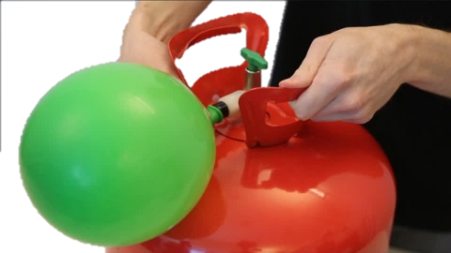
- You are inflating balloons with helium for a birthday party. As you put more and more helium in the balloon, you see the balloon getting bigger and bigger.
As more helium pumps into the balloon, the balloon gets bigger. More molecules of gas take up more space. This is an illustration of Avogadro’s Law, which states that the volume is proportional to the amount of an ideal gas.

- You are inflating balloons with helium for a birthday party. You continue filling one balloon with helium until it pops.
This example combines Avogadro’s Law with the Ideal Gas Law to explain what happened to the balloon. As in #10, when more gas is pumped into the balloon, the volume of the balloon will increase to maintain pressure on the elastic. This illustrates Avogadro’s Law.
However, once the elastic reaches its maximum stretch-limit, the volume of the balloon can no longer increase. At this point, if gas continues to be pumped into the balloon, it will result in higher and higher pressure (PV=nRT, where n is increasing but V can no longer increase, therefore P must increase). When the pressure is greater than the elastic can stand, the balloon will burst.

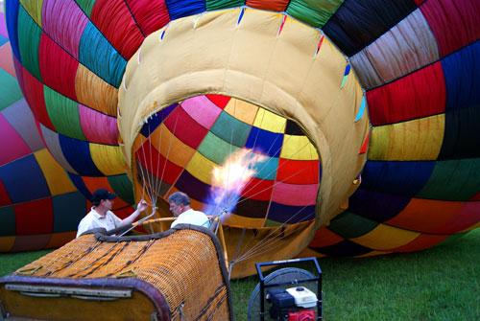
- You watch as a balloonist heats the air in a hot-air balloon, causing the balloon to inflate and rise.
The balloonist initially uses a fan to blow air into the balloon, illustrating Avogadro’s Law, stating that an increase in the amount of gas will increase the volume of the balloon. However, once the balloon is partially inflated, the balloonist turns on the flame at the base of the balloon, heating the air inside. This increase in temperature results in an increase in the volume of the air inside, filling the balloon and illustrating Charles’s Law. Because the warmer air inside the balloon is less dense than the cooler air outside the balloon, the balloon will begin to rise (float).

