Name: _______________________________ Pd: ___ Ast: _____
PROPERTIES OF GASES STUDY GUIDE
Describe the behavior of ideal gases according to each of the gas laws below:
- Boyle’s Law –
- Charles’s Law –
- Gay-Lussac’s Law –
- Avagadro’s Law –
For an ideal gas, keeping all other variables constant, describe the relationship between:
- temperature and pressure
- temperature and volume
- pressure and volume

For each real-life scenario, use the gas laws to explain the behavior of gases.
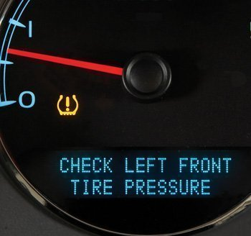
- On a cold morning, your parent starts up the car and the tire pressure light comes on signaling low tire-pressure.

- You fill up two balloons with the same amount of air. You place one in sunlight for an hour and the other in your refrigerator for an hour; then you compare them to find that they are no longer the same size.

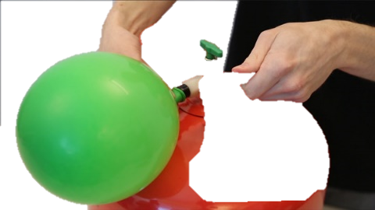
- You are inflating balloons with helium for a birthday party. As you put more and more helium in the balloon, you see the balloon getting bigger and bigger.

- You are inflating balloons with helium for a birthday party. You continue filling one balloon with helium until it pops.

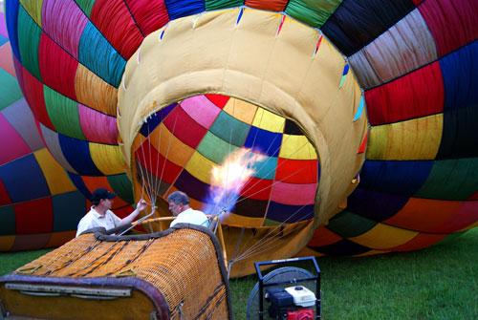
- You watch as a balloonist heats the air in a hot-air balloon, causing the balloon to inflate and rise.

