Name: ______________________________ Pd: ___ Week 3 Distance Learning
MOTION
Use the resources on Mr. Hanna’s website to complete the following assignment.
VOCABULARY:
- REFERENCE POINT –
- SPEED –
- VELOCITY –
- ACCELERATION –
- SLOPE –
SHORT ANSWER:
- How can you tell if an object is in motion or not?
- Compare the concepts of “speed” and “velocity”.
- List three ways an object can accelerate.
- When you’re calculating acceleration and get a negative number, what does that tell you?
- How can you determine the speed of an object by looking at a distance vs. time graph?
PRACTICE PROBLEMS:
- How fast is a turtle moving if it crawls 1.5 m in 60 s?
- What is the velocity of a car if it takes 5 s for it to drive 55 m?
- What is the acceleration of a golf cart if it takes 4 s for it to speed up from 0 m/s to 10 m/s?
INTERPRETING GRAPHS:
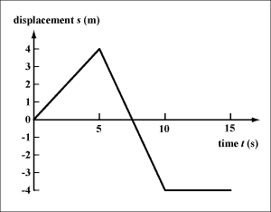
- Describe the motion of an object that produces the data shown here (to the right) on a distance vs. time graph.

- Sketch a distance vs. time graph for an object that travels forward at a constant speed of 1 m/s for 5 s, stands still for 2 seconds, then begins forward again at a speed of 2 m/s.

