Name: ______________________________ Pd: _____ Ast: _____

Eyes of Nye: Nuclear Energy Discussion

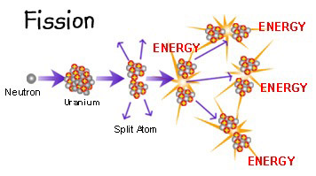
- Describe the fission process of uranium.

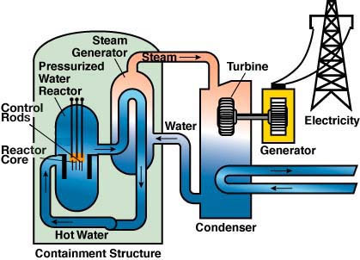
- How do nuclear power plants use the fission process to produce useable energy?

- Why was Yucca Mountain selected as the site for nuclear waste storage?

- What are some of the problems we face when deciding how to deal with nuclear waste?

- Complete a list of pros and cons for nuclear energy as a power source for our society.
Nuclear Energy
Pros | Cons

