Closing in on Fusion Energy
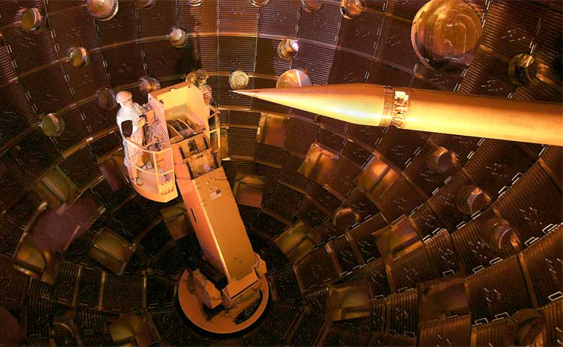
With 192 laser beams and a tiny amount of hydrogen, scientists take one step closer to harnessing a powerful energy source BY STEPHEN ORNES
9:00AM, FEBRUARY 17, 2014
https://student.societyforscience.org/article/closing-fusion-energy

Last September, scientists fired 192 laser beams all at once at a pebble-sized plastic capsule. Inside the capsule: a layer of frozen hydrogen. The brief blast lasted only 160 trillionths of a second. Still, it was powerful enough to set off a flurry of reactions in which the cores, or nuclei, of hydrogen atoms fused together. This nuclear fusion released enough energy to also cause other nearby nuclei to fuse. Those fused nuclei released enough energy to keep the reaction going — if only briefly.
This photo shows workers performing maintenance on the target chamber at the National Ignition Facility. The pencil-shaped feature on the right will hold a capsule containing hydrogen while laser beams fire at it from all directions.
Nuclear fusion is the reaction that powers the sun and other stars. Scientists have dreamed of a day when controlled fusion reactions might unleash huge amounts of energy here on Earth, too. But that hasn’t happened yet. Researchers still need to figure out how to get a fusion reaction to release more energy than it needs to get started. And once those reactions start, they need to keep going — on their own — until engineers choose to turn them off.
For that to happen, scientists must create a chain of ongoing reactions in the hydrogen. That step is called ignition. Although the new experiment didn’t achieve ignition, it did provoke a very excited reaction among scientists. They hailed it as a modest milestone on the road to harnessing nuclear fusion. Indeed, the new test produced almost 10 times as much energy as previous fusion trials that had been triggered by lasers.
The researchers conducted the experiment at the National Ignition Facility (NIF) in Livermore, Calif. Their new results appear in the Feb. 12 Nature.
“It’s a very important milestone,” Steven Rose told Science News. “However,” he adds, “there are many other milestones to pass.” A physicist at Imperial College London, Rose did not work on the study.
The goal
Nuclear fusion occurs only at extremely high temperatures and pressures. During this process, the cores of two atoms join together to form a new and bigger element, at least briefly. Usually, these atoms must have very light nuclei. Hydrogen is the lightest of all: Its nucleus normally contains only one particle: a proton. The experiment in Livermore, however, used heavier isotopes of hydrogen. That means the nucleus of each atom contained an extra particle (neutron) or two. When two heavy-hydrogen atoms fuse, they form a single helium nucleus. The process also sheds a neutron — and lots of energy.
In stars, the reaction between hydrogen nuclei releases enough energy to trigger other nuclei to fuse. That, in turn, sheds even more energy. And this triggers still more fusion reactions. The process continues until the stars begin to run short on fuel.
Scientists want to create that same reaction in the laboratory, but on a much smaller scale. Once started, the chain reaction should continue to release heat for generating electricity — until engineers turn a fusion reactor off. What makes the process so attractive is its hydrogen fuel is so plentiful. If scientists succeeded in igniting self-sustaining — and controlled — nuclear fusion, Earth should possess an almost limitless source of energy.
The hitch: Achieving ignition is extremely difficult. In 2009, NIF scientists predicted that if lasers could squash the frozen hydrogen to one thirty-fifth of its original size, the fuel’s temperature would soar to 50 million degrees Celsius (90 million degrees Fahrenheit). Under those conditions, fusion should begin — and, eventually, produce more energy than the lasers had delivered to get the whole process started.
“A lot of people thought this would be a walk in the park,” Robert McCrory recalls. A physicist at the University of Rochester in New York, he often works on NIF projects.
NIF hasn't reached ignition, however. The experts don't know why, but hydrogen doesn’t easily compress. Instead, the capsules of this fuel often warp into bulbous shapes. They then tear apart before much fusion takes place.

The challenge
“Mother Nature doesn’t like putting a lot of energy into small volumes,” notes physicist Omar Hurricane, “so she fights you on it.” He worked on the new study at the Lawrence Livermore National Laboratory, where NIF is based.
In the new laser-fusion tests, the plastic shell with hydrogen inside was sealed inside a small gold cylinder, called a hohlraum. Lasers blasted it with 1.8 million joules of energy. Only about half of one percent — some 11,000 joules — made it to the hydrogen. The remaining energy was lost. Still, enough energy reached the fuel to start fusing hydrogen.
The experiment produced about 5,100 trillion fusion reactions. Together, they released 14,000 joules of energy. That is more energy than reached the hydrogen pellet. The rub: It’s also far, far less energy than what the lasers originally shot at the target.
For comparison, imagine a candy store in another city offered $1.27 worth of candy for $1. But to get to the candy store, you first had to buy a $162.64 bus ticket. So you could end up with 27 cents’ worth of free candy — but only after spending $163.64 in total. That is a lot more than $1. Clearly, that would not make sense to do. Similarly, triggering fusion power with lasers is not yet affordable. But scientists are convinced that with much work, it will be.
For now, they’re looking for a way to spend less energy on the setup. And the new experiment suggests they're on the right track.
That’s why, Hurricane explains, after hearing about this latest experiment, “A lot of people are jazzed.”

Questions:
- What is the main problem scientists face using fusion to power the world’s energy needs?

- What happens to hydrogen atoms during nuclear fusion?

- What is “ignition” and why hasn’t it been achieved by the scientists yet?

- The hydrogen pellet in this test released 14000 Joules of energy, which is more energy than it absorbed. What keeps this process from being efficient?

- How does the candy analogy illustrate the problem with nuclear fusion as a power source?

