Four New Elements Complete the Seventh Row of The Periodic Table
By Nala Rogers
4 January 2016 http://news.sciencemag.org/chemistry/2016/01/four-new-elements-complete-seventh-row-periodic-table?

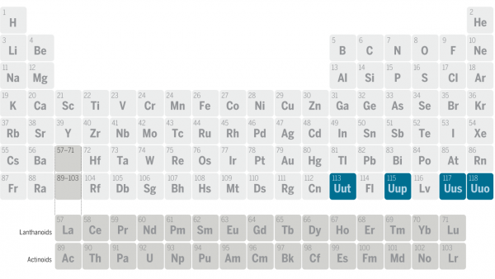
That periodic table poster on your wall is about to be out of date, thanks to four new chemical elements that just received official recognition. The newcomers are some of the heaviest ever discovered, with atomic numbers of 113, 115, 117, and 118. They will be named by the researchers who identified them, the final step before the elements take up their rightful places in the seventh row of the periodic table.
Chemists classify elements by the number of protons per atom, which they call atomic number. Elements with more than 92 protons are unstable and not normally found in nature, but researchers have worked for decades to synthesize them and prove their brief existence. The International Union of Pure and Applied Chemistry (IUPAC) assesses the evidence for each new element, deciding when it’s strong enough to warrant official recognition and who should get credit for the discovery.
Researchers first claimed to have created the heaviest known element, No. 118, in 1999, but the data in that study turned out to be fabricated (see story below). The real discoveries of the four new elements came between 2002 and 2010, thanks to a series of experiments with particle accelerators. The particle accelerators fired beams of lighter nuclei at samples of heavy elements, smashing the atoms together until some of them fused. IUPAC credited a team of Russian and U.S. scientists with the discovery of elements 115, 117, and 118. Element 113 will become the first element to be named in Asia, with credit going to a group of Japanese researchers at the RIKEN Nishina Center for Accelerator-Based Science in Wako.
The experiments offered more than a checklist of new elements. By studying how the massive nuclei of the new elements decay, researchers gained insight into the forces that hold atoms together. According to their findings, elements heavier than any yet created might have conformations that are especially stable—suggesting that if we can ever make atoms that big, they might stick around for longer than a few microseconds.

Elements 116 and 118 Were a Sham
By Charles Seife
15 July 2002 http://news.sciencemag.org/2002/07/elements-116-and-118-were-sham

The sham "discovery" of elements 116 and 118 seems to be a case of scientific misconduct, according to officials at Lawrence Berkeley National Laboratory (LBL), who have dismissed a scientist for fabricating data. Although the lab won't name the physicist at the center of the controversy, it appears to be Victor Ninov. He was in charge of the data analysis of the experiment and was subsequently fired from the laboratory.
In 1999, physicists at LBL announced that they had discovered elements 118 and 116 by smashing lead nuclei and krypton nuclei together (ScienceNOW, 7 June 1999). The news gave LBL a major edge in the high-stakes competition to push the edge of the periodic table. However, when other scientists tried to replicate the experiment, they failed. The team from LBL then reanalyzed its original data. Shockingly, the crucial evidence for the "discovery," cascades of alpha particles that accompany the deterioration of a superheavy element, were nowhere to be seen (ScienceNOW, 30 July 2001). The lab concluded that the supporting data were fabricated and dismissed a staff scientist in May for his role in the misconduct.
A spokesperson at LBL refused to describe details of the misconduct or even to mention Ninov's name, but he confirmed that Ninov indeed led the initial analysis effort in the element 116 and 118 experiments. He also confirmed that Ninov was dismissed for scientific misconduct.
On 15 July, all the authors of the original discovery paper but one--Victor Ninov--published a retraction of their claim in Physical Review Letters. (Although Ninov's name appears on the retraction, he apparently refused to sign off on it.) Both elements 116 and 118 have vanished along with the spurious data.
Review Questions: Answer the questions below using text from the article to support your answers.
- How did the scientists “create” the new elements?
“particle accelerators fired beams of lighter nuclei at samples of heavy elements, smashing the atoms together until some of them fused”

- Why did the new elements have to be “created” instead of being “found” in nature?
“Elements with more than 92 protons are unstable and not normally found in nature”

- Why is the discovery of these new and heavier elements useful to scientists beyond simply adding more elements to our collection?
“elements heavier than any yet created might have conformations that are especially stable—suggesting that if we can ever make atoms that big, they might stick around for longer than a few microseconds”

- What is the role of IUPAC in the recognition of new elements?
“The International Union of Pure and Applied Chemistry (IUPAC) assesses the evidence for each new element, deciding when it’s strong enough to warrant official recognition and who should get credit for the discovery”

- How do these articles illustrate the process of scientific confirmation?
Multiple trials are important to confirm results. The fact that LBL publicized the findings before reviewing them is astonishing. When a scientific claim is made, other scientists try to reproduce the results. Until the results are confirmed by multiple sources, they cannot be accepted by the science community.

- How do these articles illustrate the importance of scientific confirmation?
This process is important to keep things like the false discovery of elements from occurring. Scientific confirmation protects us from misinformation by providing multiple sources for a claim.

Discussion Questions: Answer the questions below using your prior knowledge about science.
- Why might scientists falsify data to make it appear as if they had made a discovery?
The scientist who falsified the data stood to gain notoriety and perhaps future employment by making this discovery.

- How does the scientific community protect itself against those who might make false claims?
Scientific confirmation is an essential part of making a scientific claim. A claim must have the support of multiple sources to be taken seriously.

- What could the LBL have done to prevent the embarrassment of one member of its research team causing the institution to publish a false claim?
They should have put the results through a review process involving multiple people and multiple trials.

- Aside from the discovery of new elements, in what other areas of science do you think we should practice skepticism (requiring evidence) when new claims are made? Why?
All areas of science should require confirmation before making claims. This is important so that the general public can have faith in the findings of the scientific community in any area of study.

