Name: ______________________________ Pd: ___ Ast#: _____
Sink or Float Lab
BACKGROUND:
Density is a physical property of matter that describes how tightly packed the particles are in a substance by comparing the amount of matter in the object to the amount of space that the matter takes up. The object’s density can be calculated by dividing its mass (how much matter is in it) by its volume (how much space it takes up). Because density is a physical property of matter, it is independent of the sample size, meaning that a large sample of a substance will have the same density as a small sample of it.

Calculating the Volume of Regular Shapes Measuring Distance with a Ruler (estimating)
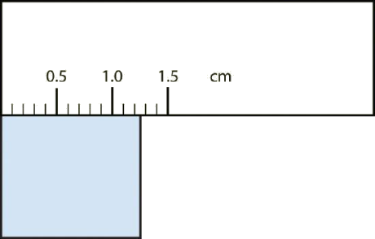
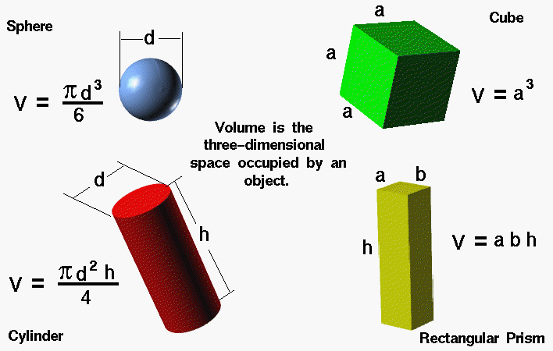
- The object falls between 1.2 and 1.3 cm
- Measure this as “1.25 cm”
- Measure in centimeters (cm)
- Line the object up with the zero line
- For more precision, estimate between lines

TASK:
Investigate the relationship between an object’s density and its ability to float.
You will need to determine what data is important to collect, how to collect it, what it means, and the best way to communicate your findings. You will have access to the following materials:

- Rulers
- Digital Scales
- Calculators
- Water
- Golf Ball
- Ping Pong Ball
- Marble
- Wooden Dowel
- Smooth Cork
- Rough Cork
- Wooden Block
- Silver Metal Block
- Gold Metal Block
- Clear Plastic Block
- Dice

GUIDING QUESTION:
What is the relationship between an object’s density and its ability to float?

TIPS:
- Use your textbook as a reference.
  - 8th Grade Text (yellow/orange) – page 122
  - Phys. Sci. Adv. Text (blue) – page 94
- Organize your data. Record every measurement/observation (label it).
- Have a purpose. Don’t use something just because it is available to use…know why/how you are using it.
- Take care of the equipment (be gentle, keep it clean)

SAFETY:
- There are no major safety concerns in this investigation.

DATA:
Use the back of this paper to organize your data.

OBJECT | MASS  (g) | VOLUME  (cm³) | DENSITY  (g/cm³) | SINK or FLOAT?
Golf Ball
Ping Pong Ball
Marble
Wooden Dowel
Smooth Cork
Rough Cork
Wooden Block
Silver Metal Block
Gold Metal Block
Clear Plastic Block
Dice

