Name: ______________________________ Pd: ___ Ast: _____
DENSITY OF WATER LAB
BACKGROUND:
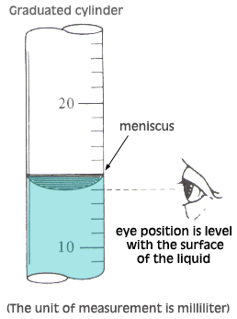
Density is a physical property of matter that describes how tightly packed the particles are in a substance. It can be useful in determining the identity of an unknown substance as well as in predicting whether an object will sink or float. Like many physical properties, density is independent of the sample-size, meaning it will be the same for a substance no matter how much of the substance you are observing. Today, we will begin exploring density by calculating it from our own measurements.
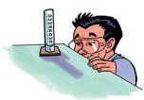
Using a Graduated Cylinder
- Place the graduated cylinder on a flat surface and view the height of the liquid in the cylinder with your eyes directly level with the liquid.
- The liquid will tend to curve downward. This curve is called the meniscus. Always read the measurement at the bottom of the meniscus.

Using a Triple-Beam Balance
  - Slide all riders back to "0" on the beams before massing any object.
  - Place the object to be massed on the pan.
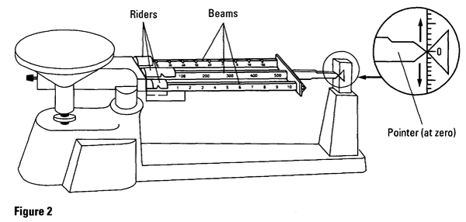
  - Gently slide the riders along the beams to determine the mass. Begin with the largest rider (middle), then the medium rider (back), then the smallest rider (front). The pointer will swing above and below the zero point while you are adjusting the riders. Adjust them until it lines up with the zero point.
  - The mass of the object will be the sum of the masses on all beams. NOTE: Make sure each rider is in a notch before reading.

TASK:
Determine the density of tap water. You will be responsible for figuring out how to calculate density, what measurements you’ll need, and how to obtain them. Your teacher will not provide you with these answers; only guidance on where to find information and how to interpret it.
You will have access to the following materials:

- Tap water
- 25 mL graduated cylinder
- Digital scale
- Triple-beam balance
- Calculators
- Science textbooks

GUIDING QUESTION:
What is the density of tap water?

TIPS:
- Use your textbook as a reference.
  - 8th Grade Text (yellow/orange) – pages 119-122
  - Phys. Sci. Adv. Text (blue) – pages 87-94
- Have a purpose. Don’t use something just because it is available to use…know why/how you are using it.
- Take care of the equipment (be gentle, keep it clean)

SAFETY:
- If a graduated cylinder breaks, the glass will be sharp and could cut you. DO NOT CLEAN UP BROKEN GLASS. Instead, ask the teacher for assistance.

DATA:
Use the bottom/back of this paper to organize your data.

