Name: ______________________________ Pd: _____ Ast: _____
Mechanical Energy Study Guide
Provide the correct term to match the following definitions:
- ______________________________: Energy associated with the motion or position of an object
- ______________________________: Energy of motion
- ______________________________: Stored Energy
- ______________________________: Energy stored in an object due to stretching or compressing it
- ______________________________: Energy stored in an object based on its height
Provide a short response to the following items:
- What is the equation for kinetic energy?

- Aside from its mass, what is the main factor that decides an object’s kinetic energy?

- What is the difference between the two types of potential energy?

- How is gravitational potential energy related to “work”?

- What is the equation for gravitational potential energy?

- What does “g” stand for? What is its value?

- Aside from its mass, what is the main factor that decides an object’s gravitational potential energy?

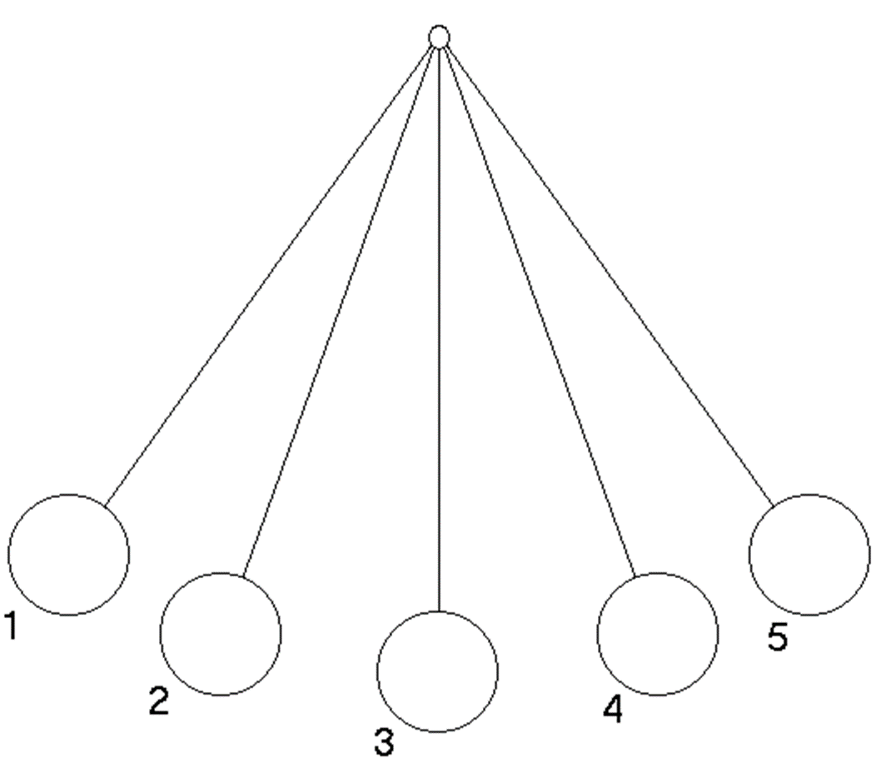
- Describe the energy conversions present when a pendulum is pulled back and released as it swings back and forth. You may use the diagram below in your explanation.

Answer the questions below based on the following scenario. If the question requires math, you must show your work. If it does not, you must explain your logic.
A 1.5 kg book is sitting on the edge of a desk that is 0.75 m tall. A student accidentally bumps the desk, causing the book to fall to the ground. Another student comes along and picks up the book, putting it back in its original position on the desk.

- At what point did the book have the most gravitational potential energy? Explain your logic.

- At what point did the book have the least gravitational potential energy? Explain your logic.

- At what point did the book have the most kinetic energy? Explain your logic.

- At what point did the book have the least kinetic energy? Explain your logic.

- How much GPE did the book have while it was sitting on the desk before it was knocked off? Show your work.

- What happened to the GPE of the book as it fell? Explain your logic.

- How much energy did the book (and/or the surrounding environment) have at the instant it hit the ground? Describe what types of energy were involved. Explain your logic.

- How much GPE did the book have as it rested on the ground? Show your work.

- How much “work” did the second student do to lift the book back to the desk? Show your work OR explain your logic.

- How much GPE did the book have when the student placed it back on the desk? Show your work OR explain your logic.

