Name: _________________________ Pd: _____ Ast: _____
M/J Physical Science Adv.: Mechanical Energy Notes
- Mechanical Energy
  - How do we define mechanical energy?

- Kinetic Energy
- Describe kinetic energy.

- What does the word “kinetic” mean?

- What factors influence kinetic energy?

- Write the equation for kinetic energy.

- What units must you use in order to have “Joules” as the unit of kinetic energy?

- Kinetic Energy Calculations
- A 0.6 kg basketball is thrown at a velocity of 9 m/s. How much Kinetic Energy does it have? (ALWAYS SHOW YOUR WORK!)

- A 7 kg bowling ball is rolling down the lane with a velocity of 8 m/s. How much Kinetic Energy does it have? (ALWAYS SHOW YOUR WORK!)

- Potential Energy
- Describe potential energy.

- Explain the difference between the two types of potential energy.

- Gravitational Potential Energy
- What factors influence gravitational potential energy?

- Write the equation for gravitational potential energy.

- What does “g” mean? What is its value (including units)?

- Write an alternative equation for potential energy using the weight of an object.

- How does gravitational potential energy relate to “work”?

- Potential Energy Calculations
- A 0.6 kg basketball is held above a player’s head. The ball is 2 m above the ground. How much potential energy does it have? (ALWAYS SHOW YOUR WORK!)

- A 1.0 kg textbook is placed on a shelf 1.5 m above the ground. How much potential energy does it have? (ALWAYS SHOW YOUR WORK!)

- Mechanical Energy Conversions
- What type of energy did the clay ball from the lab have before you dropped it?

- As the clay ball fell, what happened to the GPE?

- Describe the energy conversions involved in the launch of your figurine in the lab. Draw a diagram to help explain.

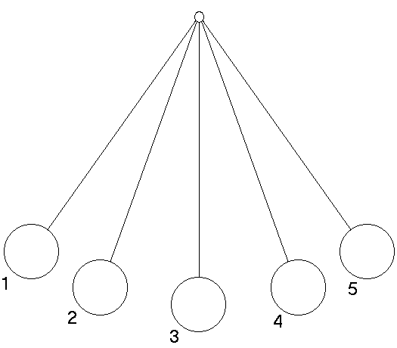
- Use the diagram of a pendulum swinging left to right (shown below) to answer the following questions:
    - Where is the KE at its maximum? Why?

    - Where is the GPE at its maximum? Why?

    - Where does it have both KE and GPE?

