Name: _________________________ Pd: _____ Ast: _____
Mechanical Energy Lab
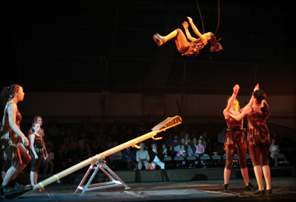
INTRODUCTION: The law of conservation of energy states that energy is neither created nor destroyed; instead, energy is converted into different forms or transferred into other objects. Depending on the system, however, some energy may be exchanged with the surrounding environment. Circus performers using a teeter-board to launch acrobats into the air is an example of such a system. For the performers, knowing exactly how high the acrobat will be launched is very important, so they must understand how to manipulate the energy in the system to consistently influence the height of the launched acrobat. In this investigation you will use a model of a teeter-board to explore this relationship between mechanical energy and launch height.
Figure 1 – A circus act uses a teeter-board to launch an acrobat into the air.
Mechanical energy is energy that is based on the motion or position of an object. There are two types of mechanical energy, kinetic energy and potential energy. When energy is stored in one form or another it is called potential energy. Chemical energy and nuclear energy could be considered types of potential energy, since they depend on energy that is stored in chemical bonds and in the nuclei of atoms. Mechanical energy, however, is stored based on the position of an object. When objects are lifted off the ground, they are given gravitational potential energy (GPE). GPE depends on the object’s mass, the acceleration due to gravity on Earth (constant), and the height of the object. We use the equations:

GPE = m x g x h (g = 9.8 ^{m}/_{s}²) or GPE = W x h (W = m x g)

When potential energy is used to set an object in motion, it is converted into kinetic energy (KE). KE depends on the mass of the object and how fast it is moving (its velocity). It is calculated using the equations:

KE = (½) x m x v² or KE = (m x v²) ÷ 2

Acrobats using a teeter-board to launch a person into the air is an example of conversions between KE and PE.

TASK: Use at least three different masses of clay and a teeter-board to launch a figurine exactly 40 centimeters (0.4 m) into the air (average height between 39 cm and 41 cm). Determine the relationship between the mass of the clay and the drop height required to get the correct launch height.

QUESTION: How is the mass of clay related to the drop height required to launch the figurine 40 cm high?
MATERIALS: You may use any of the following materials in your investigation:

- Teeter-Board
- Plastic Figurine
- Two Meter Sticks (m)
- Digital Scale
- Clay Ball (as much or as little clay from the ball as you want to make 3 different masses)

SAFETY PRECAUTIONS:
- Objects should only be dropped, not thrown. (For consistency and responsibility.)
- Refrain from standing directly over the teeter-board when an object is dropped. (Protect your face!)
- Take care to prevent your figurine from being launched into another group’s work station (This is not a height contest!).

GETTING STARTED: Take some time before you launch your figurine to think about how GPE and KE are involved in this process. This may be an appropriate situation to use trial-and-error as a research method. Think about how averages provide more reliable data than a lone measurement.

