Name: ______________________________ Pd: _____ Ast: _____
Thermal Energy & Heat Notes
- Thermal Energy vs. Temperature
  - TEMPERATURE: ___________________________________________________________________________
________________________________________________________________________________________
  - THERMAL ENERGY: ________________________________________________________________________
________________________________________________________________________________________
    - _____ the __________ of each _______________ together
    - faster-moving particles have more __________ __________, and therefore a higher ____________________.
  - Objects with the same thermal energy do NOT necessarily have _____ ______ _______________.
  - Objects with the same temperature do NOT necessarily have _____ ______ _________ ________.
  - Compare the thermal energy and temperature of the water in beaker X and beaker Y:
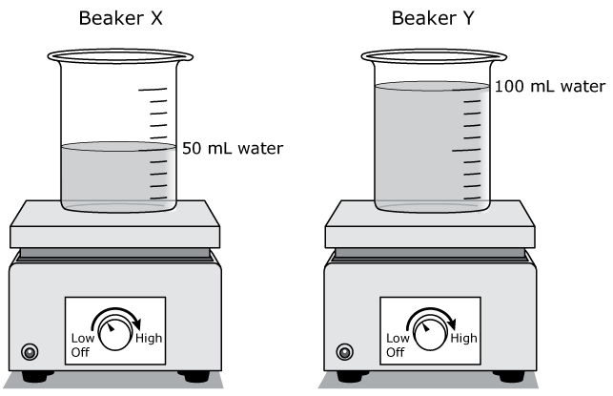
- Beaker X: 50 mL at 22°C & Beaker Y: 100 mL at 22°C

- Beaker X: 60 mL at 5°C & Beaker Y: 60 mL at 25°C
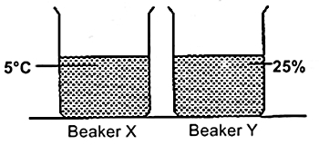

- Temperature Scales
- _______________ ( ) – Commonly used ______________________.
- __________ = Freezing Point of Water __________ = Boiling Point of Water
- _______________ ( ) – Commonly used ____________________________________________.
- __________ = Freezing Point of Water __________ = Boiling Point of Water
- _______________ ( ) – Commonly used _________________________________.
- __________ = Freezing Point of Water __________ = Boiling Point of Water
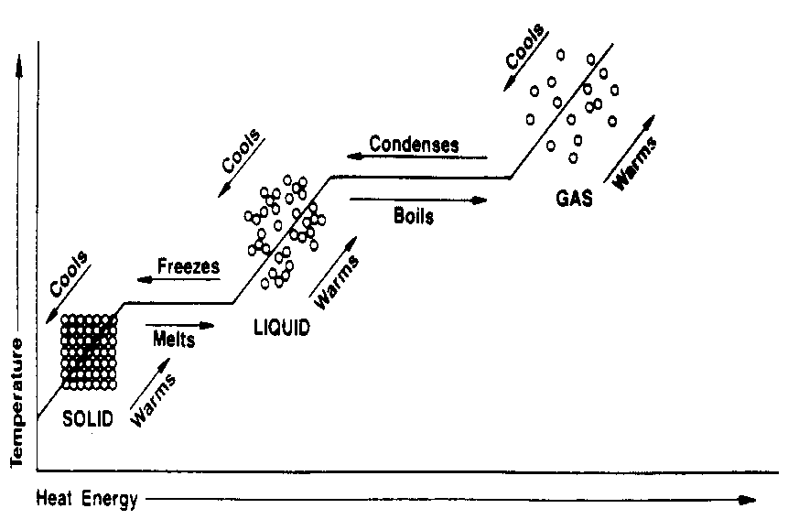
- “_______________ __________” ( ) means NO particle motion at all
- Temperature & Molecules
- What does a rise in temperature indicate?

- What does a drop in temperature indicate?

- What happens to the temperature during a phase change?
- HEAT: ____________________________________________________________________________________
__________________________________________________________________________________________
- CONDUCTION: ____________________________________________________________________________
- The particles of one substance _______ _______ the particles of another substance
- Examples from the Heat Lab:

- CONDUCTOR: ______________________________________________________________________
      - Examples:
      - All of these have a _______ __________.
- INSULATOR: _______________________________________________________________________
      - Examples:
      - All of these have a _____ __________.
- CONVECTION: ____________________________________________________________________________
- CONVECTION CURRENT: __________________________________________________
      - Warmer _____-_______ fluid _______ while cooler _____-_______ fluid _______, creating a _____ or __________.
      - Example from the Heat Lab:

- RADIATION: ______________________________________________________________________________
- For example, we get heat from __________, mainly from __________ waves.
- Radiation does NOT require __________ to transfer energy…heat can be transferred through __________ _______.
- Example from the Heat Lab:

- “Heat flows in one direction.”
- Heat flows from _____________ objects to _____________ objects until both have _____ _______ temperature (they have reached their “____________________” temperature).
- Heat will flow from _____________________ to ____________________.
- Heat will flow from _____________________ to ____________________.
- Heat will flow from _____________________ to ____________________.
- If you hold an ice cube in your hand, why does your hand feel cold?

      - There is no such thing as “_______”...only an _______________ ___ ____________ __________.
- Why will a can of soda freeze if you place it in the freezer?

