BAN DIHYDROGEN MONOXIDE!
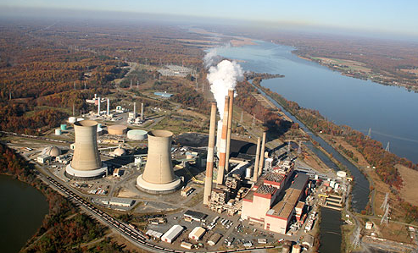
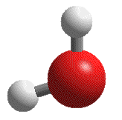
Dihydrogen monoxide (DHMO) is colorless, odorless, tasteless, and kills uncounted thousands of people every year. Most of these deaths are caused by accidental inhalation of DHMO, but the dangers of dihydrogen monoxide do not end there. Prolonged exposure to its solid form causes severe tissue damage. Symptoms of DHMO ingestion can include excessive sweating and urination, and possibly a bloated feeling, nausea, vomiting and body electrolyte imbalance. For those who have become dependent, DHMO withdrawal means certain death.

Dihydrogen monoxide:
- is also known as hydroxyl acid, and is the major component of acid rain.
- contributes to the "greenhouse effect."
- may cause severe burns.
- contributes to the erosion of our natural landscape.
- accelerates corrosion and rusting of many metals.
- may cause electrical failures and decreased effectiveness of automobile brakes.
- has been found in excised tumors of terminal cancer patients.

Contamination is reaching epidemic proportions!
Quantities of dihydrogen monoxide have been found in almost every stream, lake, and reservoir in America today. But the pollution is global, and the contaminant has even been found in Antarctic ice. DHMO has caused millions of dollars of property damage in the Midwest, and recently California.

Despite the danger, dihydrogen monoxide is often used:
- as an industrial solvent and coolant.
- in nuclear power plants.
- in the production of Styrofoam.
- as a fire retardant.
- in many forms of cruel animal research.
- in the distribution of pesticides. Even after washing, produce remains contaminated by this chemical.
- as an additive in certain "junk-foods" and other food products.

Companies dump waste DHMO into rivers and the ocean, and nothing can be done to stop them because this practice is still legal. The impact on wildlife is extreme, and we cannot afford to ignore it any longer!
The American government has refused to ban the production, distribution, or use of this damaging chemical due to its "importance to the economic health of this nation." In fact, the navy and other military organizations are conducting experiments with DHMO, and designing multi-billion dollar devices to control and utilize it during warfare situations. Hundreds of military research facilities receive tons of it through a highly sophisticated underground distribution network. Many store large quantities for later use.

DHMO must be banned, and large companies and military organizations must be held accountable for its use.
Name: ______________________________ Pd: ___ Asmt: _____
Ban Dihydrogen Monoxide Questions
Answer the following questions:
- What is the cause of most dihydrogen monoxide-related deaths?

- What are some other chemicals/substances which commonly kill people in a similar way?

- What does it mean to become “dependent” on DHMO?

- What are some other substances that cause people to become dependent on them?

- How do you think DHMO “pollution” became global, even being found in Antarctic ice?

- If DHMO is global, how does it affect us in Tallahassee?

- Are humans responsible for the abundance of DHMO in our ecosystem? Why or why not?

- What do you think should be done about DHMO? Should the U.S. Government get involved?

- What are your thoughts on the United States military’s research into utilizing DHMO in combat situations? What about the military’s storage of DHMO in underground distribution networks?

- Are you comfortable with the knowledge that large quantities of DHMO are being stored for “later use”? Explain your answer.
DHMO Class Discussion
Ask these questions to the class after they’ve read the article and answered the questions on their paper. It is important that the discussion occur before the class knows that dihydrogen monoxide is actually “water”.

- What do you think is the author’s purpose for writing this article?
- Is the article scientific? If yes, what makes it scientific? If no, what makes it non-scientific?
- What is the author’s claim?
- What evidence does the author use to support his/her claim?
- Is the author’s evidence convincing?

This is where you’ll reveal the truth…
- What if I told you that you have been contaminated with DHMO? What if I told you that every person in this room is already addicted to DHMO?
- WHAT IF I TOLD YOU THAT DHMO IS ANOTHER NAME FOR WATER?
  - “Dihydrogen Monoxide” means two hydrogen atoms (“di” means two) and one oxygen atom (“mono” means one) form this molecule.
  - The pictures of the molecules on the article are water molecules showing two hydrogens bonded to one oxygen atom
- How does this knowledge change your opinion of the article?
  - Read through the article again knowing that DHMO is water…
    - Colorless, odorless, tasteless…
    - Deaths are caused by “accidental inhalation”…a.k.a. – drowning
    - Prolonged exposure to solid form (ice) causes tissue damage (frost bite)
    - Excessive ingestion causes sweating and urination, bloated feeling, etc…
    - For those dependent (everyone), withdrawal means certain death
    - Major component of acid RAIN
    - Erosion of natural landscape (rain)
    - Corrosion of metals (rust)
    - Found in tumors of cancer patients (our bodies are mostly water)
    - Found in every stream, lake, and reservoir in America (and the rest of the world)
    - Found in Antarctic ice
    - Used as a coolant and fire retardant
    - Used in animal research (animals gotta drink too!)
    - Food is contaminated even after washing…with water…
    - Millitary controlling and utilizing it during warfare (soldiers gotta drink too!)
    - Underground distribution network…a.k.a. – plumbing
    - Stored for later use (water towers)
- How does this article highlight the importance of science literacy?
  - As a future voter, were you willing to “BAN” dihydrogen monoxide?
  - Can the public be manipulated using scientific jargon? Can the public be manipulated with pseudoscience (something pretending to be scientific but is not actual science)?

