Name: ______________________________ Pd: _____ Ast: _____
SUN & EARTH STUDY GUIDE
GRAVITY
- What role does GRAVITY play in the Sun, Earth, & Moon system (list three things)?
Gravity causes the ELLIPTICAL ORBIT of the Earth around the Sun and the Moon around the Earth
Gravity causes the SPHERICAL SHAPE of the Sun, Earth, and Moon (gravity pulls mass toward the center)
Gravity causes the TIDES in Earth’s oceans (The Moon’s gravitational pull on the Earth)
- How does Earth’s ROTATION around its axis affect its shape (ie: the equatorial bulge)?
Because Earth is spinning, the centrifugal force causes it to bulge at the EQUATOR, meaning the circumference around the equator is longer than it is around the poles.
EARTH’S ORBIT
- What is the shape of Earth’s ORBIT around the Sun?
Earth has an ELLIPTICAL orbit
- Where is the Sun in relation to Earth’s ORBIT?
The Sun is located at one of the focal points of the ELLIPSE
- How does a “YEAR” relate to Earth’s movement?
One year corresponds to one full REVOLUTION of the Earth around the Sun
- How does a “DAY” relate to Earth’s movement?
One day corresponds to one full ROTATION of Earth around its axis of rotation
- Why do we say that Earth is “TILTED”?
Earth’s AXIS OF ROTATION is tilted 23.5° from its orbital plane. This causes the HEMISPHERES to receive differing amounts of DIRECT/INDIRECT SUNLIGHT throughout the YEAR.
SUN’S ENERGY
- What types of energy does Earth receive from the Sun?
RADIANT Energy – Light & THERMAL Energy – Heat
- When the NORTHERN HEMISPHERE is tilted toward the Sun, how does it affect the energy we receive from the Sun (think about the flashlight activity)?
When the Northern Hemisphere is tilted toward the Sun, it gets more DIRECT SUNLIGHT. The energy is more concentrated, causing the average temperature to be higher.
- When the NORTHERN HEMISPHERE is tilted away from the Sun, how does it affect the energy we receive from the Sun (think about the flashlight activity)?
When the Northern Hemisphere is tilted away from the Sun, it gets INDIRECT SUNLIGHT. The energy is less concentrated (spread out over a larger area), causing the average temperature to be lower.
SEASONS
- What causes Earth’s SEASONS?
The seasons are caused by EARTH’S tilt and the resulting direct/indirect sunlight hitting each hemisphere.
- Compare the length of daylight hours and the average temperature during the SUMMER and the WINTER.
SUMMER – longer daylight hours, higher average temperature due to DIRECT sunlight
WINTER – shorter daylight hours, lower average temperatures due to INDIRECT sunlight
- Explain why the NORTHERN and SOUTHERN HEMISPHERES always have opposite SEASONS to one another.
When one hemisphere is tilted toward the Sun, the other is tilted away. This means that while one is getting direct sunlight the other is getting indirect sunlight.
- What is the significance of a SOLSTICE? When does a SOLSTICE occur?
Solstices are the longest/shortest days of the year depending on the hemisphere. Solstices occur when one hemisphere is tilted directly toward the Sun and the other away. This happens in June (Summer) and December (Winter).
- What is the significance of an EQUINOX? When does an EQUINOX occur?
Equinoxes are days when each hemisphere receives 12 hours of daylight and 12 hours of darkness because the Sun is directly over the equator. This occurs in September (Fall) and March (Spring).
SEASONS DIAGRAM - Label the following on the diagram below for just the NORTHERN HEMISPHERE.
- Seasons for the NORTHERN HEMISPHERE (Summer, Winter, Spring, Fall)
- Soltices (June & December)
- Equinoxes (September & March)
- Length of Days for the NORTHERN HEMISPHERE (longest day, shortest day, equal day/night)
- Light in NORTHERN HEMISPHERE (Direct, Indirect)

WINTER
December Solstice
Shortest day
Indirect sunlight

SPRING
March Equinox
12 hours daylight
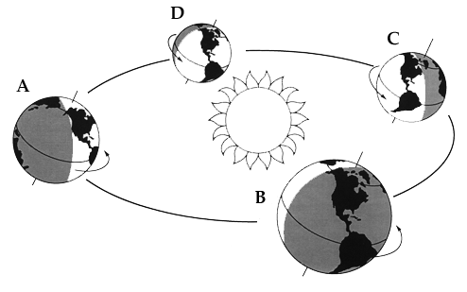
FALL
September Equinox
12 hours daylight
SUMMER
June Solstice
Longest day
Direct sunlight

