Name: _______________________________ Pd: ___ Ast: _____
Seasons Diagram
Considering only the Northern Hemisphere at each location, fill in the season, solstice or equinox, relative length of daylight hours, and whether there is direct or indirect sunlight.

D:
C:

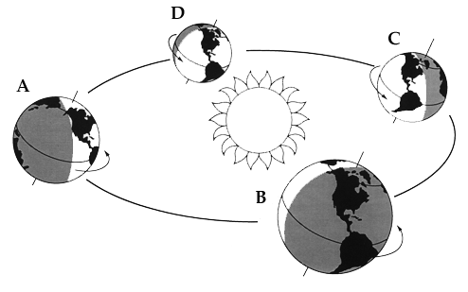
B:
A:

