Name: ______________________________ Pd: _____ Ast: _____
Moon Study Guide
VOCAB
TIDES PHASES ORBIT LUNAR ROTATION ECLIPSE REVOLUTION
- The word, _______________, means “related to the moon”.
- ____________________ and ____________________ both refer to an object moving around another object in a path similar to a circle.
- When an object spins around its own axis it is called ____________________.
- The reason the Moon has _______________ is because its relative position to the Earth and the Sun changes as it orbits, causing different parts of the illuminated Moon to be visible from Earth.
- When one celestial object blocks sunlight from another celestial object (casts its shadow on the other object), it is called an _______________.
- The Moon’s gravitational pull causes _______________, which refers to the daily rise and fall of ocean water.
ORBIT
- Why isn’t there an ECLIPSE twice a month when the Moon is either in front of or behind the Earth?

- What shape is the Moon’s ORBIT, and where is the Earth located in relation to the Moon’s orbit?

- How long does it take for the Moon to make one REVOLUTION around the Earth?

- How long does it take for the Moon to make one ROTATION around its own axis (spin)?

- Why do we always see the same side of the Moon from Earth?

PHASES
The sun-lit half of the Moon appears and then disappears from right to left over the course of one month…
- What is the term for the moon as the visible lit portion grows from New Moon to Full Moon?

- What is the term for the moon as the visible lit portion shrinks from Full Moon to New Moon?

- When we see less than a quarter moon, it is called…

- When we see more than a quarter moon, it is called…

TIDES
- What causes ocean TIDES on Earth?

- Where on Earth does HIGH TIDE occur?

- When would you observe the strongest/highest HIGH TIDE (Where would the Sun, Earth, and Moon be located)?

ECLIPSES
- What happens during a SOLAR ECLIPSE?

- What happens during a LUNAR ECLIPSE?

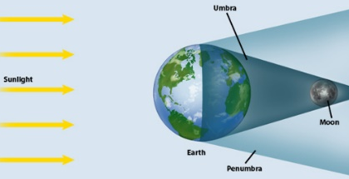
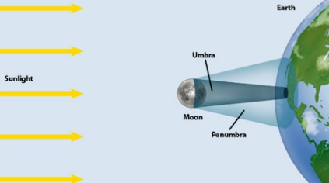
- Label the diagrams below as either “LUNAR ECLIPSE” or “SOLAR ECLIPSE”.

PUTTING IT TOGETHER
Use the diagram below to answer the following questions:
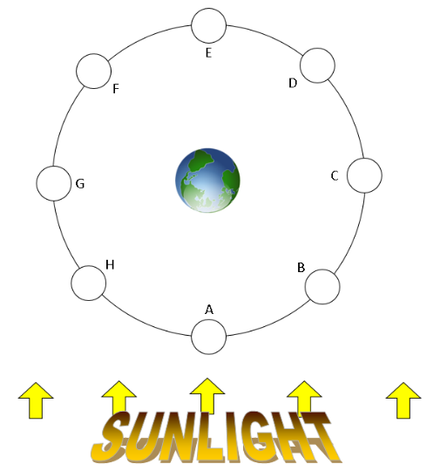
- Which position represents the location of a “New Moon”?
- Which position represents the location of a “Full Moon”?
- Where on the diagram would the Moon be “WAXING”?
- Where on the diagram would the Moon be “WANING”?
- Where on the diagram would the Moon be “CRESCENT”?
- Where on the diagram would the Moon be “GIBBOUS”?
- Which position represents the location of the Moon during a LUNAR ECLIPSE?
- Which position represents the location of the Moon during a SOLAR ECLIPSE?
- If there is a high tide at midnight but no moon is visible, where is the Moon?
- If high tide occurs at sunrise and again at sunset, where could the Moon be?
- Where would the Moon be during the strongest/highest TIDE?

