Name: ______________________________ Pd: _____ Ast: _____
Moon Questions
For each question listed below, write a short response and draw a diagram to support your answer.
- Does the Moon ORBIT the Sun or the Earth? Explain your answer.
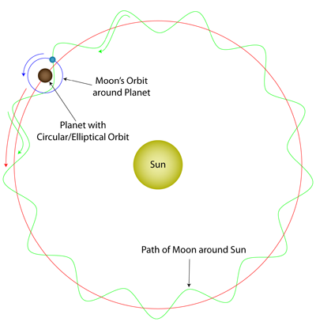
The Moon orbits the Earth as the Earth orbits the Sun, so you could say that the Moon orbits both. However, the simplest answer is that the Moon is in orbit around the Earth, as it completes about 12 full revolutions around the Earth in the time that it completes 1 full revolution around the Sun.
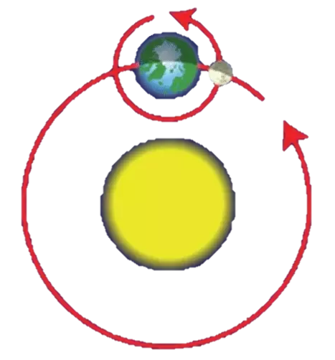

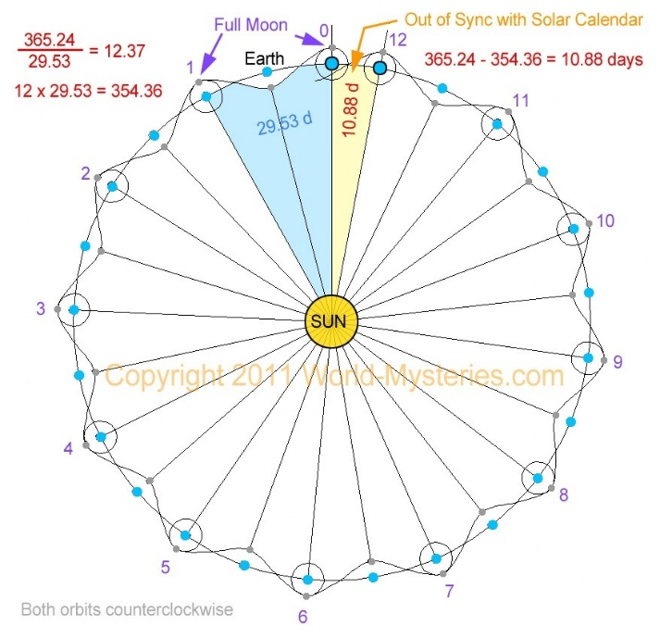
- Why does a MONTH occur every 28-31 days?
One month is about the time that it takes the Moon to complete one full revolution around Earth (@29.5 days). There are 12 months in the year because the Moon completes roughly 12 revolutions around the Earth each year, but with almost 11 days “extra”. These 11 extra days are the reason that some “months” are a few days longer (30-31 days).

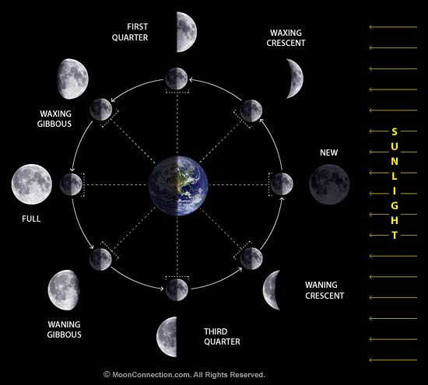
- Why do we observe different PHASES of the Moon?
As the Moon completes its orbit of Earth, different parts of the Moon are visible from Earth. This is because only the half of the Moon facing the Sun is illuminated at any given time. From Earth, we see parts of the lit-half of the Moon and parts of the un-lit-half (the shaded side) of the Moon each day. This results in the phases we see each month.

- Some people incorrectly think that the Moon only comes out at NIGHT. Why is the Moon sometimes visible during the DAYLIGHT?
As the Moon orbits the Earth, sometimes it is on the “daytime” side of Earth. During this time, part of the visible side of the Moon is lit by the Sun, allowing us to see the Moon while it’s daytime. Of course, during a new moon, the moon will be invisible in the daytime sky.
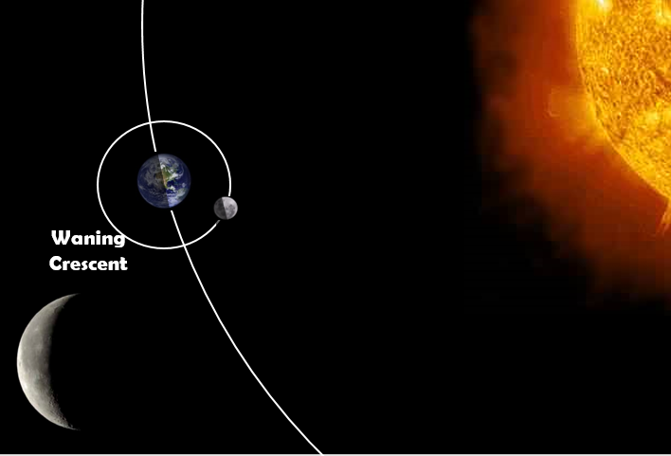
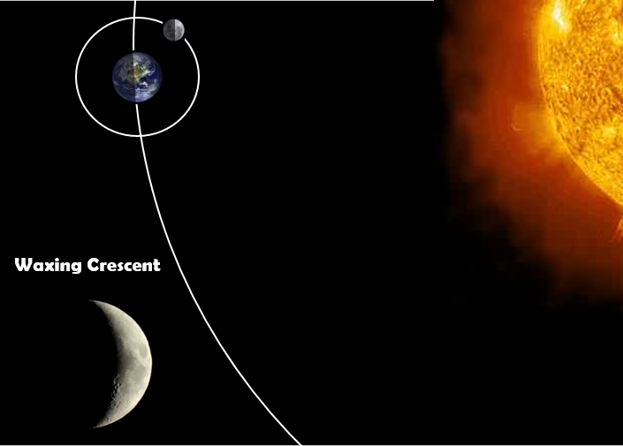

- Why does the ocean TIDE come in twice each day (about every 12 hours)?
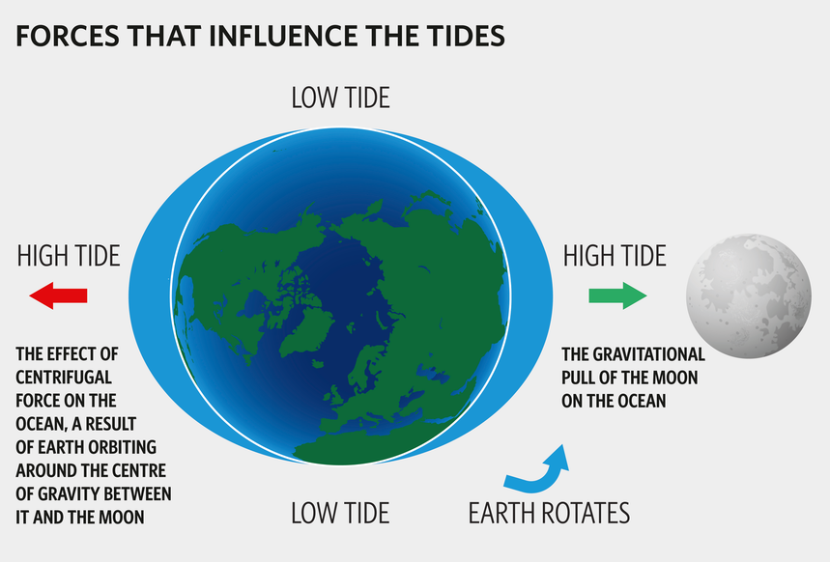
There is always a high tide at two locations on Earth at any given time, on the side of Earth facing the Moon and the opposite side of Earth. As Earth rotates, a given location will rotate into and out of each of these high tides every day, resulting in a high tide about once every 12 hours.

- Why don’t we have an ECLIPSE twice each month (during the new moon and full moon phases)?
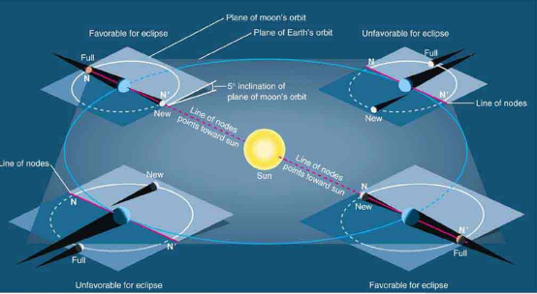
The Moon’s orbit is tilted about 5° from Earth’s orbital plane, so it only crosses Earth’s orbital plane at two points along its orbit, called “nodes”. An eclipse can only happen if the Moon is positioned at one of these two nodes at the exact time when the Sun, Earth, and Moon line up.

