Name: _________________________ Pd: _____ Ast: _____
Moon Phases Diagram
Shade the appropriate side of each moon. In the boxes, draw what the moon will look like from Earth.
Full Moon

Waxing Gibbous
Waning Gibbous

E

D
F

First Quarter
Third Quarter

C
G

B
H

Waxing Crescent
Waning Crescent
A

New Moon

SUNLIGHT

Look at the picture of the Moon on the left. Apply what you learned about the positions of the Sun, Earth, and Moon and their effect on the Moon’s phases to complete the diagram to the right. The arrows indicate the direction of the sunlight.
- Shade in the appropriate side of the Earth to show day vs. night.
- Draw the Moon where it must be in order to appear as it does in the picture from Earth.
- Shade in the appropriate side of the Moon to show why it appears in the identified phase.

- First Quarter
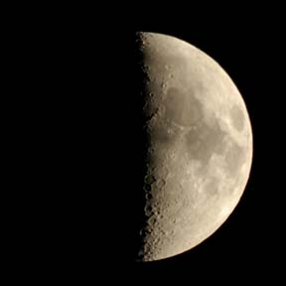

E

- Full Moon
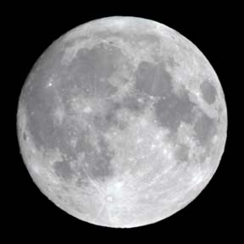

E

- Waning Crescent
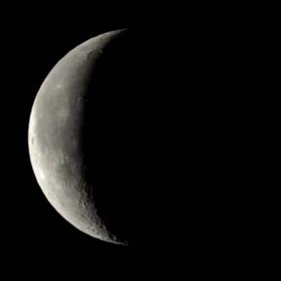
E

