Name: ______________________________ Pd: ___ Ast: _____
DENSITY OF WATER LAB

GOAL:
Determine the density of tap water.
Collect evidence to support your answer through measurement and observation. Remember that density (like most physical properties) is independent of the sample size, so you’ll want your data to show that water has the same density regardless of amount.

SAFETY:
If a graduated cylinder breaks, the glass will be sharp and could cut you. DO NOT CLEAN UP BROKEN GLASS. Instead, ask the teacher for assistance.

DENSITY:
Find “density” on page 122 of your textbook and answer the following questions.
- What is “density”?

- What two measurements must you know in order to calculate density?

- What SI units do we use for the density of a substance?

VOLUME:
Find “volume” on page 121 of your textbook and answer the following questions.
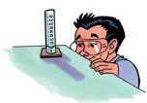
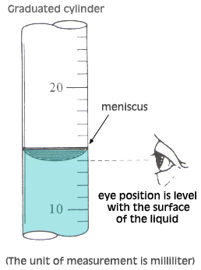
- What is “volume”?

- Tap water is a liquid. What SI units do we usually use for the volume of a liquid?

Measure a volume of 10mL of water using a graduated cylinder.
Using a Graduated Cylinder
- Place the graduated cylinder on a flat surface and view the height of the liquid in the cylinder with your eyes directly level with the liquid.
- The liquid will tend to curve downward. This curve is called the meniscus. Always read the measurement at the bottom of the meniscus.

MASS:
Find “mass” on page 119-120 of your textbook and answer the following questions.
- What is “mass”?

- How does the force of gravity affect an object’s mass?

- What SI units do we usually use for the mass of a substance?

Determine the mass of 10mL of water.
- What is the mass of the graduated cylinder with 10mL of water?
- In order to find the mass of the water, we must subtract the mass of its container (the graduated cylinder). What is the mass of the empty graduated cylinder?
DATA TABLE:
TRIAL # | VOLUME OF WATER  (mL) | MASS OF CONTAINER WITH WATER  (g) | MASS OF EMPTY CONTAINER  (g)
1 | 10 mL
2 | 25 mL
3 | 50 mL
4 | 75 mL
5 | 100 mL

CALCULATIONS:
TRIAL # | VOLUME OF WATER  (mL)  record the volume of water from the data table above for each trial | MASS OF WATER  (g)  subtract the mass of the container from the mass of the container with water | DENSITY OF WATER  (g/mL)  divide the mass of the water by the volume of the water
1
2
3
4
5

CONCLUSIONS:
- Did you get similar results for the density of water for all five trials?

- Should we expect the density of water to be the same for all five trials? Explain your answer.

- What is the average density of tap water based on your measurements? (add up the densities for each trial and divide by the number of trials)

- Recall the definitions of mass, volume, and density. When we calculate an object’s density, what is it that we’re actually describing about that substance?

- Read about density on pages 122 and 124 of your textbook. What are two ways that we can use density to learn about an unknown substance?

