Name: ______________________________ Pd: _____ Ast: _____
The Universe
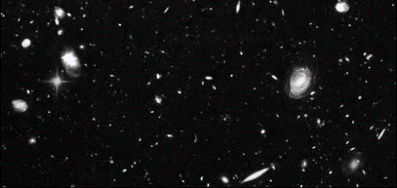
¹Gazing into the sky on a clear night, you will see thousands of visible stars twinkle and shine. It seems like space and the stars go on forever, but what is really out there? Have you ever wondered if maybe we are not alone, and that somewhere out there an Earth-like planet is orbiting some other star with intelligent life forms asking the same question? You are not the only one who has pondered this question. Astronomers have been studying the night sky since the beginning of time. They have a pretty good idea about what is out there and what makes up the universe. Composed of objects like galaxies, stars, and nebulae, the universe is everything that exists; including space, time, matter, and energy.
Figure 1: This image from the Hubble Telescope shows a section of space with many different types of galaxies.
¹³The universe is home to billions of galaxies. Each galaxy can contain a few million to hundreds of billions of stars that are held together by their gravity. There are different types of galaxies as shown in Figure 1. Our galaxy, the Milky Way, is a spiral galaxy. A spiral galaxy forms new stars in its spiral arms and spins through space like a hurricane. Our solar system is located in one of the spiral arms of the Milky Way. On a clear, dark night, a milky band runs across the sky. This is the central portion of our galaxy. Including the Sun, the Milky Way contains approximately 200 billion stars. Another type of galaxy is called an elliptical galaxy. Elliptical galaxies are shaped like an oval and contain old, red stars. They do not have enough gas to create new stars. Some galaxies have an irregular shape and so are called irregular galaxies. These galaxies come in many shapes and sizes and are constantly forming new stars.
²¹New stars are born within galaxies. Many galaxies contain giant clouds of dust and gas, which help create new stars. The clouds, called nebulae, appear in a variety of shapes, sizes, and colors. An emission nebula appears to be a pinkish-red color. The hydrogen atoms inside the nebula emit a red light that makes the cloud glow. Reflection nebulae, just like its name, reflect the light of other stars. They appear to be blue. The affect is similar to what makes the sky appear blue on Earth. The nebula cloud scatters the blue light and lets the other colors of light pass through undisturbed. Dark nebulae seem to produce no light, because the stars are not close enough to them. They appear as a dark spot in space. A planetary nebula is a result of a star, like the Sun, expanding to become a red giant. Despite its name, it has nothing to do with the planets. It appears to have a colorful ring around it.
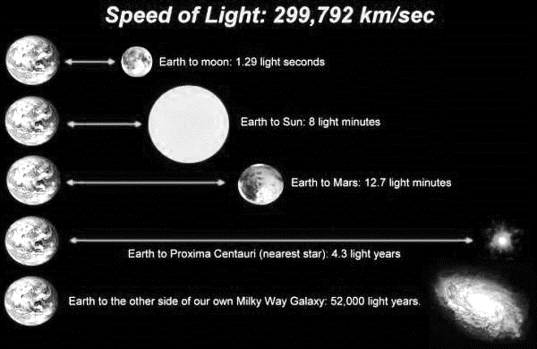
²⁹Scientists estimate that the universe contains at least one hundred billion galaxies. Considering that our galaxy contains about one-hundred-thousand-million stars, scientists estimate that there are about one-billion-trillion stars in the universe. Because of the incredible distances between stars, the twinkling light that you see at night may have been on its way to Earth for thousands, or maybe even millions, of years. In this way, looking up into the night sky is like looking into the past. The distance that light from a star can travel in one year is known as a light-year. It takes 4.3 years for light to travel to Earth from Proxima Centauri, the nearest star to our Solar System. It takes light 52,000 years to reach Earth from the other side of our own galaxy. Imagine how long it took the light from distant galaxies to travel to the Hubble Telescope when it took the picture in Figure 1!
Figure 2: This image illustrates the distances between celestial objects using the concept of a light-year.
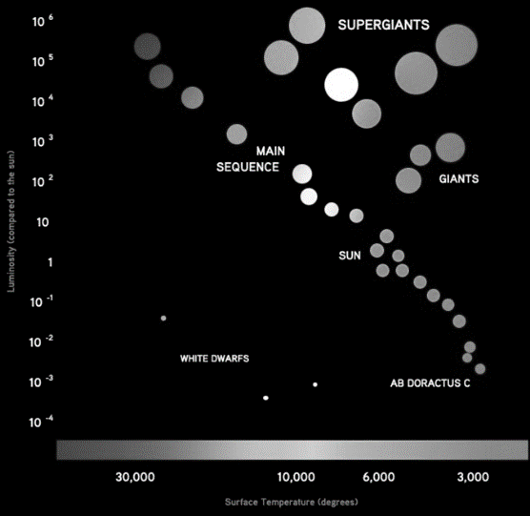
⁴⁸If you look up into the night sky, you’ll find it’s hard to tell a difference among the stars. However, if you look at them through a telescope, you’ll notice that they appear to be different colors. The stars’ age and temperature determine what color of light we see. The hottest stars appear blue, while the coolest stars appear red. Stars range in size from smaller than Earth (neutron stars) to thousands of times larger than the Sun (red supergiants). When scientists classify stars, they use a tool called the Herztsprung-Russell diagram (HR diagram) which is shown in Figure 3. Each star is placed on the diagram according to its temperature and brightness. The vertical axis of the diagram compares the stars’ brightness to that of our Sun; the brighter stars are above and the dimmer ones below. The horizontal axis arranges the stars by temperature, with the hotter stars toward the left. As you can see in Figure 3, patterns emerge when the stars are arranged this way, allowing astronomers to learn more about them based on where they are grouped in the diagram.
Figure 3: A Herztsprung-Russell diagram (HR diagram) shows how the brightness of stars relates to their temperature.
⁶⁷Astronomers believe the universe could be about 13 billion years old. By studying the galaxies, stars, and nebulae that create stars, scientists understand more and more about our universe, its formation, and our place within it. The next time you wonder if we are alone in space, think about all the great astronomers who have studied the night sky in search of the same answer.

Use the passage above to answer the questions below. Be sure to cite the line(s) where you found your answer.
- What is the universe?

- How are galaxies classified? What type of galaxy is the Milky Way?

- Where can nebulae be found?

- How is looking into the night sky like looking into the past? What does this mean about observations that scientists make by looking at distant stars/galaxies?

- Using the HR diagram in figure 3, how is the brightness of a “main sequence” star related to its temperature?

