Name: ______________________________ Pd: _____ Ast: _____
Stars & Galaxies Study Guide
- Vocabulary: Know the definitions of the following words.
  - ASTRONOMICAL UNIT (A.U.)
  - LIGHT YEAR
  - STAR
  - NUCLEAR FUSION
  - NEBULA
  - APPARENT MAGNITUDE
  - MAIN SEQUENCE STAR
  - SUNSPOTS
  - GALAXY
- Proxima Centauri (the nearest star to our Sun) is about 4.3 light years away from Earth. Explain what this means.

- Why are nebulae (plural for “nebula”) important celestial (space) regions?
- What is the cause of nuclear fusion? Where does it occur in stars such as our Sun?
- What occurs during nuclear fusion?
- What is the result of nuclear fusion?
- How are stars classified? How does this relate to the color of a star?
- How do scientists measure the brightness of objects in the sky?
- What characterizes a main-sequence star? (What makes them different from Red Giants or Supergiants?)
- What determines how long a star remains a main-sequence star?
- Describe the life cycle of a low-mass star.

- Describe the life cycle of a high mass star.

- About how long do scientists expect that our Sun will remain on the main sequence? How far through its lifespan do they think it is?
- How did Galileo discover that our Sun rotates?
- Describe the Sun’s location and motion in relation to the Milky Way.
- What type of galaxy do we most likely live in?
- What are some other “types” of galaxies?
- Relate the following concepts: Galaxy, Galaxy Cluster, Nebula, Solar System, Star, Star Cluster, Universe

- Scientists observe that all galaxies are moving away from one another. What does this lead them to conclude?

For the following questions, refer to the H-R diagram shown to the right.
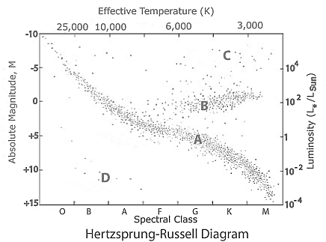
- What information is shown on an H-R diagram?
- Where is our Sun in comparison to other stars on the H-R diagram?

- Which letters on the HR diagram to the right correspond to the following types of stars?

- ____ Supergiants (fuse heavier elements than carbon)
- ____ Red Giants (fuse helium to carbon)
- ____ Main Sequence (fuse hydrogen to helium)
- ____ White Dwarf (fuse heavier elements than carbon)

The “spectral class” categories are listed as letters along the bottom of the graph.
- Which spectral class identifies the hottest stars? What color are they?

- Which spectral class identifies the coolest stars? What color are they?

- Which spectral class is our Sun? What color is it?

- Main-sequence stars are represented as a diagonal line on an H-R diagram. What does this indicate about the relationship between the temperature and brightness of main-sequence stars?

- Based on the H-R Diagram shown, compare a Class-B main-sequence star to a Class-K main-sequence star.

