Name: ______________________________ Pd: ___ Ast: _____
Solar System Map Activity
On the diagram of the football field shown below, fill in where each planet would be if the Sun is on one goal line.
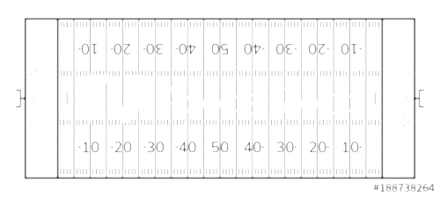
SUN

- In the above analogy, how big is:
- The Sun
- Earth
- Mercury (the smallest planet)
- Jupiter (the largest planet)
- What is an Astronomical Unit (AU)?

- For each solar system object below, record its distance from the Sun in AU’s:
- _____ - Mercury
- _____ - Venus
- _____ - Earth
- _____ - Mars
- _____ - Asteroid Belt
- _____ - Jupiter
- _____ - Saturn
- _____ - Uranus
- _____ - Neptune
- _____ - Pluto
- Which planet is one and a half times further from the Sun than Earth?
- Which planet is nearly twice as far away from the Sun as Jupiter?
- Which planet is about 25% closer to the Sun than Earth?
- Which planet is nearly 20 times farther from the Sun than Earth?
- Which planet is about 30 times farther from the Sun than Earth?

