Name: ______________________________ Pd: ___ Ast: _____
Exoplanet with Rain and Clouds of Water Droplets?
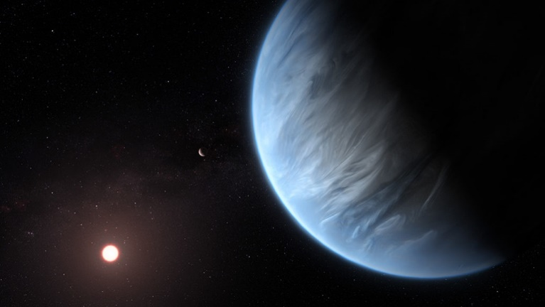
Lisa Grossman SEPTEMBER 11, 2019
https://www.sciencenews.org/article/first-known-exoplanet-rain-clouds-water-droplets

Clouds of water droplets and even rain may exist in the soggy skies of a faraway exoplanet.
A combination of observations with space telescopes and simulations suggests that planet K2 18b has water vapor in its atmosphere, and might be the first planet orbiting a distant star found to support liquid water, thought to be an essential ingredient for life.
Exoplanet K2 18b, shown in the foreground of this artist’s impression, may be the first temperate planet in another star system found with a watery atmosphere, and perhaps even clouds and rain.
“Water vapor exists everywhere in the universe,” says astronomer Björn Benneke of the University of Montreal, who reported the potential discovery in a paper posted September 10 at arXiv.org. “But it’s not so easy to make liquid water; you need the right pressure and the right temperature. That’s what makes this planet special.”
The exoplanet-hunting Kepler space telescope discovered K2 18b in 2015. The planet orbits a dim red dwarf star about 110 light-years away, and is bigger and heavier than Earth: about 2.5 times Earth’s radius and about eight times its mass.
“From the beginning, that makes it not an Earthlike planet,” astronomer Angelos Tsiaras of University College London, whose team independently detected water vapor in K2 18b’s atmosphere in a study published September 11 in Nature Astronomy, said in a Sept. 10 news teleconference. But tantalizingly, the planet’s distance from its star places it in the habitable zone, the region around a star where a planet could have temperatures conducive to liquid water (SN: 6/14/17).
In 2016 and 2017, a group led by Benneke used the Hubble Space Telescope to probe K2 18b for signs of an atmosphere as the planet passed in front of its star. Molecules in the planet’s atmosphere absorbed certain wavelengths of the star’s light, alerting astronomers to their presence.
Tsiaras and colleagues accessed that data from a public archive and used specially designed software to analyze it. The team found that the planet has an atmosphere, and that the atmosphere imprints the telltale signature of water vapor molecules on the filtered starlight. The atmosphere also contains hydrogen and helium, the team reports.
“Until now, the planets for which we had the atmosphere observed and found water were gas giants, planets more similar to Jupiter, Saturn or Neptune,” Tsiaras says. K2 18b’s location in the habitable zone, size and watery atmosphere mean that “this is the best candidate for habitability that we now have.”
Benneke and colleagues took the work a step further and observed K2 18b with the Spitzer space telescope. The combination of Hubble, Spitzer and Kepler observations suggests that clouds form at a certain level in the planet’s atmosphere, absorbing more starlight than at other levels, the team found.
When Benneke and colleagues simulated the planet’s climate, they found that the region where the clouds condense could have the right pressure and temperature for liquid water to form. That means liquid water droplets could condense out of the clouds and rain down, Benneke says.
“It’s quite likely that this planet has liquid rain on it,” he says. “This is actually one of the most exciting findings from this data.”
Benneke thinks K2 18b’s raindrops would never hit solid ground. Instead, they would reach a point in the planet’s thick atmosphere where the pressure and temperature were so great that the droplets would evaporate. Then the water would rise up in the atmosphere again, condense into clouds, and rain back down. “There’s a bit of a water cycle,” he suggests.
Other exoplanet experts remain skeptical. “There is no definitive proof” of raindrops, says astronomer Sara Seager of MIT. “It’s a solid but still speculative statement.”
But liquid water, if it exists on K2 18b, doesn’t mean anything lives — or can live — on the planet. Its size places the exoplanet somewhere between the girth of Earth and Neptune, meaning it’s not clear if it has a rocky surface where life as we know it could evolve. Most exoplanets in the Milky Way fall in this size range, but it’s hard to tell if they’re rocky super-Earths, gassy mini-Neptunes or sodden water worlds (SN: 6/19/17).
“It’s one of these really mysterious planets that are the most common type of planet in our galaxy, as far as we can tell,” Seager says. “We have no idea what they are.” Future observations with NASA’s planned James Webb Space Telescope may be able to pin down how much water K2 18b contains, which would help figure out its composition, she says (SN: 4/19/16).

Use the article above to answer the following questions.
- Why is it so difficult for there to be liquid water?

- How far away from us is planet K2 18b?

- How does the size of K2 18b compare to Earth?

- What makes K2 18b the best candidate for habitability we have right now?

- What factors make it unlikely that life could exist on K2 18b?

